

BRAZIL: AN APPLICATION OF PORTER’S DIAMOND AND

ATTRACTIVENESS ANALYSIS FOR FRENCH FDI

Renata Rondon Cunha

Project submitted as partial requirement for the conferral of

Master in International Management

Supervisor:

Álvaro Augusto Rosa, Assistant Professor, ISCTE Business School, ISCTE- IUL

October 2013


BRAZIL: AN APPLICATION OF PORTER’S DIAMOND AND

ATTRACTIVENESS ANALYSIS FOR FRENCH FDI

Renata Rondon Cunha

- Spine -
Brazil: An application of Porter’s Diamond and attractiveness analysis for French FDI

Resumo

A atratividade de um país é medida pelo retorno de custo de capital, que deve ser maior ou igual ao obtido em outro negócio e com um nível aceitável de risco de operação a seus funcionários e acionistas. Para tal avaliação, as oportunidades de mercado e riscos do país são balanceados e comparados a outros países de características similares.

A estagnação da economia europeia tem gerado entre os países europeus a necessidade de expandir seus horizontes à outras partes do globo onde a economia é mais dinâmica e propícia a resultados positivos.

França é o país escolhido como um investigador de novos mercados. Empresas francesas beneficiam-se consideravelmente de investimentos no Brasil, não somente pelo seu crescimento e economia estável, mas também pela poderosa influência em toda a América Latina. O Brasil pode ser a porta de entrada para investimentos franceses nesta região.

Esta dissertação parte da teoria de atratividade e do Diamante de Michael E. Porter para analisar as indústrias e setores em que o Brasil possui vantagem competitiva. Cada atributo do diamante é analisado para evidenciar tal competitividade. Deste modo, algumas qualidades que pareçam fraqueza, podem ser consideradas como oportunidade para investimentos em termos de competitividade mundial.

O estudo feito analisa os dados através de fatos correntes e atual situação econômica do mercado brasileiro, em busca dos pontos economicamente atrativos como país alvo de investimento estrangeiro direto (IED) francês.

Finalmente, os resultados desta pesquisa reveem o uso do Diamante Nacional para a atratividade do país.

Palavras-chave: Diamante de Porter, atratividade de um país, França e Brasil, relação econômica

JEL Classification System: F23 and O54

V

Brazil: An application of Porter’s Diamond and attractiveness analysis for French FDI

Abstract

The attractiveness of a country is measured by the return of the cost of capital that has to be equal or higher than those made elsewhere and holding an acceptable operational risk to the investor’s employees and shareholders. In order to reach this assessment it is necessary to weigh and compare the markets’ opportunities as well as the country risks with other similar countries.

The stagnation of the European economy has generated amongst the European countries the need to expand their horizons to other parts of the globe where the economy is more dynamic and favourable to positive results.

France is the chosen country as a seeker for new markets. French companies benefit largely from investing in Brazil not only because of its growing and steady economy but also by the powerful influence in all Latin America.

This dissertation is based upon the attractiveness theory and of Michael E. Porter’s Diamond designed to analyse the industries and sectors in which Brazil has competitive advantage. Each attribute of the diamond is studied to explain such competitiveness. Thus, some qualities that may be seen as a weakness can be considered an opportunity of investment in terms of world-wide competitiveness.

This study analyses data through the lens of current facts and economic situation of Brazilian market revealing its economically attractive points as a target country for French foreign direct investment (FDI).

In conclusion, the findings of the research revise the use of the National Diamond analysis on country’s attractiveness for investment.

Keywords: Porter’s Diamond, country attractiveness, France and Brazil, economic relation

JEL Classification System: F23 and O54

VI

Brazil: An application of Porter’s Diamond and attractiveness analysis for French FDI

Executive Summary

Em tempos de crise econômica europeia, mesmo os países mais estáveis e com economia forte buscam meios de sobreviver e manter a economia favorável. Ao mesmo tempo, os países em ascendência aproveitam a oportunidade para impor-se em termos mundiais e conquistar o seu espaço.

Esta dissertação busca através da ferramenta teórica do Diamante de Michael E. Porter, analisar a vantagem competitiva do Brasil e sua atratividade para outros países.

Como alvo de investimento, o Brasil é o país escolhido para este estudo por ser o “B” dos BRIC e pela atual exposição mundial. Muito falado atualmente mas ainda visto com ressalvas, este país tem se mantido entre os maiores em termos de PIB e está em busca de infraestrutura, tecnologia e educação de países desenvolvidos.

Como investidor, o país escolhido é a França. Um importante país europeu que deve buscar parceiros para manter seu desenvolvimento e crescimento positivo.

Os dois países em questão possuem boas relações políticas e econômicas, vários investimentos e parcerias bilaterais, inclusive estratégicas.

Este estudo visa enfatizar, com auxílio da ferramenta teórica escolhida, as características das indústrias e setores brasileiros, bem como possiblidades de investimento pelas empresas francesas, através de exemplos práticos de atividades com capacidade de absorção de novos negócios.

VII

Brazil: An application of Porter’s Diamond and attractiveness analysis for French FDI

Acknowledgements

I would like to thank Professor Álvaro Rosa for his guidance and encouragement as my supervisor throughout this dissertation writing.

I also thank my friend Maria Teresa Lobato Cardoso for her assistance and advise.

Special thanks to Jorge Yuri de Lion Yamane, my husband, his support, patience and love make everything possible.

Finally, I would like to thank my parents, Marcia and Carlos, and family for all their support, faith and understanding.

VIII

Brazil: An application of Porter’s Diamond and attractiveness analysis for French FDI

 |  |  | Contents
1 | Introduction .................................................................................................................... |  |  | XV
2 | Brazil |  | ................................................................................................................................. | 16
 | 2.1 | Demography and geography ................................................................................................. |  | 16
 | 2.1.1 |  | Region’s features ............................................................................................................... | 17
 | 2.2 | Politics ..................................................................................................................................... |  | 19
 | 2.3 | Economy .................................................................................................................................. |  | 20
 | 2.3.1 |  | Brazilian Clusters .............................................................................................................. | 24
3 | Literature review ............................................................................................................. |  |  | 29
 | 3.1 | Diamond of National Advantage .......................................................................................... |  | 31
 | 3.1.1 |  | Industries classification ..................................................................................................... | 34
 | 3.1.2 |  | The patterns of Brazil competitive advantage ................................................................... | 34
 | 3.1.3 |  | Factor Conditions .............................................................................................................. | 41
 | 3.1.4 |  | Demand Conditions ........................................................................................................... | 44
 | 3.1.5 |  | Related and Supporting Industries .................................................................................... | 45
 | 3.1.6 |  | Firm Strategy, Structure and Rivalry ................................................................................ | 47
 | 3.2 | Synthesis of Porter’s Diamond Analysis .............................................................................. |  | 48
4 An overview of France business prospect ...................................................................... |  |  |  | 50
 | 4.1 | Demography, geography and politic .................................................................................... |  | 50
 | 4.2 | Economy .................................................................................................................................. |  | 50
 | 4.3 | Foreign direct investments .................................................................................................... |  | 51

IX

Brazil: An application of Porter’s Diamond and attractiveness analysis for French FDI

 | 4.3.1 | Presence in Brazil .............................................................................................................. | 52
 | 4.3.2 | Investment opportunities in Brazil .................................................................................... | 55
 | 4.3.3 | Joint declaration between the governments ...................................................................... | 57
5 | Conclusion ........................................................................................................................ |  | 59
6 | Bibliography ..................................................................................................................... |  | 62
7 | Appendix ........................................................................................................................... |  | 71
 | 7.1 Estimative of Brazilian resident population in 01/07/2010 (IBGE, Estimativas de
 | população, 2013) ............................................................................................................................... |  | 71

7.2 Cluster of Internationally Competitive Brazil Industries, 2010, elaborated by the author (International Trade Centre, Products, 2010), (International Trade Centre, Services, 2010) . 72

7.3 The Global Competitiveness Report 2013-2014 (World Economic Forum, 2013) 76

7.4 Country Attractiveness Index 2013 (Groh, Liechtenstein, & Lieser, 2013) 76

X

Brazil: An application of Porter’s Diamond and attractiveness analysis for French FDI

List of figures

Figure 1: Map of Brazil, with division of Regions and States (adapted from IBGE, Mapas) . 18

Figure 2: Reproduction of The Determinants of National Advantage (Porter, 1990, p. 72) 33

Figure 3: Structure of MERCOSUR Common Nomenclature (adapted from MDIC, 1988) 34

Figure 4: The Cluster Chart (adapted from Porter, 1990, p. 288) 39

Figure 5: Share of Exports of the World and Brazil by Cluster, in 2010 (elaborated by the

author) 40

XI

Brazil: An application of Porter’s Diamond and attractiveness analysis for French FDI

List of tables

Table 1: Estimative of population (referring to 2012) for the six most populated cities in

Brazil (IBGE, Estimativas de população, 2013) 17

Table 2: GDP Ranking of 2010 and 2011 (The World Bank, 2011) 21

Table 3: GDP per capita, PPP of 2010 and 2011 (The World Bank, Search, 2011) 21

Table 4: Brazilian GDP global and per capita of 2010, by region (Data Source: IBGE, 2012,

p. 18) 22

Table 5: Percentage of Gross Value Added (GVA) at basic prices, by region in 2010 (IBGE,

2012, pp. 22-23) 23

Table 6: Gross Value Added (GVA) at basic prices, by region in 2010 (Data Source: IBGE,

Contas Regionais do Brasil, 2012) 24

Table 7: Model and sources assessment for Brazil in 2013 30

Table 8: Top Fifty Brazilian’s Industries in Terms of World Export Share, 2010 (elaborated

by the author, Data Source: International Trade Centre, Products, 2010) 37

Table 9: Brazilian Services in Terms of World Export Share, 2010 (elaborated by the author,

Data Source: International Trade Centre, Services, 2010) 38

Table 10: Top ten French companies in Brazil (Exame, 2011) 52

Table 11: France Trade balance with exports to Brazil (Data Source: International Trade

Centre, 2013) 52

XII

Brazil: An application of Porter’s Diamond and attractiveness analysis for French FDI

List of Abbreviations

ANCINE National Cinema Agency (Agência Nacional do Cinema)

BA Bahia State

BRIC Brazil, Russia, India and China

CE Ceará State

DF Federal District (Distrito Federal)

EMBRAER Brazilian Aeronautic Company (Empresa Brasileira de Aeronáutica)

FDI (IED) Foreign Direct Investments (Investimento Estrangeiro Direto)

GDP (PIB) Gross Domestic Product (Produto Interno Bruto)

GVA Gross Value Added

HS Harmonized System

HDI Human Development Index

IBGE Brazilian Institute of Geography and Statistics (Instituto Brasileiro de

Geografia e Estatística)

IMF International Monetary Fund

INSEE National Institute of Statistics and Economic Studies - France

IPEA Applied Economic Research Institute (Instituto de Pesquisa Econômica

Aplicada)

i.e. That is (to say); in other words

ITA Institute of Aeronautic Technology (Instituto Tecnológico de Aeronáutica)

MDIC Ministry of Development, Industry and Foreign Trade (Ministério do

Desenvolvimento, Indústria e Comércio Exterior)

MERCOSUR Common Market of South (Mercado Comum do Sul)

(MERCOSUL)

MG Minas Gerais State

NCM MERCOSUR Common Nomenclature (Nomenclatura Comum do Mercosul)

OECD Organization for Economic Co-operation and Development

XIII

Brazil: An application of Porter’s Diamond and attractiveness analysis for French FDI

PESTEL Political, Economic, Social, Technological, Environmental and Legal

PPP Purchasing-Power-Parity

R$ Brazilian currency: Real

RJ Rio de Janeiro State

SP São Paulo State

SWOT Strengths, Weaknesses, Opportunities and Threats

UN United Nations

UNESCO United Nations Educational, Scientific and Cultural Organization

* Between parenthesis, the translation in Portuguese, if applicable.

XIV

Brazil: An application of Porter’s Diamond and attractiveness analysis for French FDI

1 Introduction

The main objective of this paper is to provide a study on country’s attractiveness, specifically, Brazil, under the theoretical framework of Michael E. Porter’s Diamond theory in a French perspective of internationalization strategy.

The analysis of the four determinants of the National Diamond theory helps to perceive which are the industries and clusters in the target country that represents an international competitive advantage. This paper emphasizes the relevance of Brazilian’s competitive advantage and attractiveness.

Brazil as a BRIC has a significant participation in the world’s economy and the visibility it generates attracts the attention of other countries.

France is the chosen country analysed as a potential investor in Brazil.

In the context of World Trade Organization, these two nations have different characteristics in socio-economic aspects and the bilateral relationship can help them complete the missing points and balance their needs.

The choice of two countries in different continents with many dissimilarity was made to prove

a point of observation that a country considered “developing” (World Trade Organization,

2013), and other considered in common practice “developed” (United Nations Statistics,

2003) are striving in the same world economy and in the same level of offers.

The economic connections can be called as “bilateral relationship”. Little & Marandi (2003) define the bilateral relationship as “those with a high level of both action and belief components. The relationship is important to both parties economically, and considerable trust and commitment to long-term development of the relationship exists on both sides”.

The treaty signed by the presidents of France and Brazil in the meeting that took place in the end of 2012, and its agreements and contracts under way will be analysed.

XV

Brazil: An application of Porter’s Diamond and attractiveness analysis for French FDI

2 Brazil

This chapter will give a panoramic view of the fundamental characteristics of Brazil such as demography, economy and politics, with special emphasis in the current economic situation of the country.

The history of Brazil started to be written in 1500, when the Portuguese navigators landed on its shores. Because of its immense vastness of resources and the amenity of the climate, people from all over the world migrated to Brazil in search for a better life, contributing thus far to the rich melting pot that is the Brazilian culture.

The official language of Brazil is Portuguese.

The data source for many of the referential information about Brazil is from IBGE and the reports are presented in its local currency: Brazilian Real (R$).

Most part of referential data in this paper is from the year of 2010. Since the Brazilian Real has currency exchange variations, the U.S. Dollar will be used as common currency to avoid misunderstandings and comparison of different currencies.

The conversion rate was defined as the result of the division of Brazilian’s GDP of 2010 (IBGE, 2012, p. 18) in U.S. Dollar by Brazilian’s GDP of the same year (The World Bank, 2011) in Brazilian Real:

2143035000000
3770085000000
= 0,5684

The rate used to exchange Brazilian Real into U.S. Dollar is 0,5684.

2.1 Demography and geography

The population of Brazil according to the census of 2010 (IBGE, Brasil em síntese, 2013) reached the number of 190.755.799 people. The total area of Brazil is 8,515,767.049 km² (IBGE, Sala de Imprensa, 2012).

16

Brazil: An application of Porter’s Diamond and attractiveness analysis for French FDI

The country is divided in five macro regions: North, Northeast, Central-West, Southeast and South. Each macro region is composed by states with a governor. Brazil has a total of twenty-six states and the Federal District, where Brasília, the capital of the country is located.

The most populated cities are São Paulo, Rio de Janeiro, Salvador, Brasília, Fortaleza and Belo Horizonte.

City |  |  | State |  | Region |  | Population
São Paulo |  | SP |  |  | Southeast |  | 11 376 685
Rio de Janeiro |  | RJ |  |  | Southeast | 6 390 290
Salvador |  | BA |  |  | Northeast | 2 710 968
Brasília |  | DF |  |  | Central-West | 2 648 532
Fortaleza |  | CE |  |  | Northeast | 2 500 194
Belo Horizonte |  | MG |  |  | Southeast | 2 395 785


Table 1: Estimative of population (referring to 2012) for the six most populated cities in Brazil (IBGE, Estimativas de população, 2013)

2.1.1 Region’s features

To organize its statistics programme, in 1945, Brazil was divided in five macro regions. The regions were grouped in a historic and geographic perspective. The divisions are relevant to facilitate public policies and decisions regarding the economic location, social and tributary activities, planning, surveys and identification of space structures in urban and rural agglomerations.

The distribution of regions is as follows (Imprensa Nacional Brasileira, 2013, p. 48):

The North region (in Portuguese: Região Norte) is composed by seven States: Rondônia, Acre, Amazonas, Roraima, Pará, Amapá and Tocantins.

The Northeast (in Portuguese: Nordeste) region is composed by nine States: Maranhão, Piauí, Ceará, Rio Grande do Norte, Paraíba, Pernambuco, Alagoas, Sergipe and Bahia.

The Southeast region (in Portuguese: Região Sudeste) is composed by four States: Minas Gerais, Espírito Santo, Rio de Janeiro and São Paulo.

The South region (in Portuguese: Região Sul) is composed by three States: Paraná, Santa Catarina and Rio Grande do Sul.

17

Brazil: An application of Porter’s Diamond and attractiveness analysis for French FDI

The Central-West region (in Portuguese: Região Centro-Oeste) is composed by three States

and the Federal District (Brasília): Mato Grosso do Sul, Mato Grosso and Goiás.
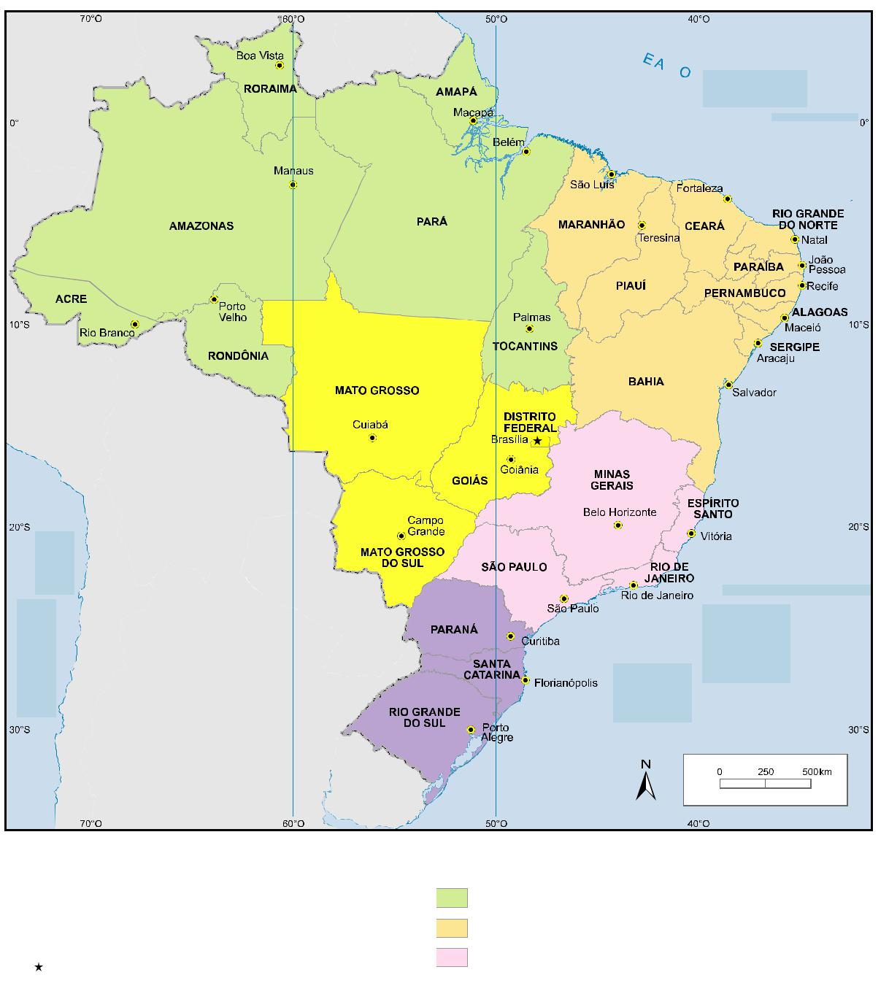

OCEAN

PACIFIC

Legend

State boundary

Country boundary

State Capital

Country Capital

ATLANTIC | OCEAN

ECUADOR

TROPIC OF CAPRICORN

ATLANTIC | OCEAN

Region

North  South

Northeast  Central-West

Southeast

Figure 1: Map of Brazil, with division of Regions and States (adapted from IBGE, Mapas)

18

Brazil: An application of Porter’s Diamond and attractiveness analysis for French FDI

2.2 Politics

The political structure of a country can greatly influence its business and the role of the Government is essential for the competitive advantage analysis. This section explains the Brazilian structural aspects in politics and the roles of each sphere in the administration system.

Brazil is a Federal Republic formed by the Union, States and Municipalities. It is a Presidential democratic system.

The Union is divided in three independent branches working harmoniously amongst them: the Legislative Power (elaborates the law), the Executive Power (executes programs, laws and provide public services) and the Judicial Power (judges, solves conflicts – it is composed by the courts in different levels: Supreme Federal Court, the Superior Court of Justice and other Superior Courts, the National Justice Council and the Regional Federal Courts) (Portal Brasil, 2009).

The Executive Power for the whole nation is headed by the President. The State level is represented by the Governor and in the Municipality sphere is represented by the Mayor.

The President, Governor and Mayor are elected directly for four years having the possibility of only one re-election in a consecutive term.

The voting system is compulsory for citizens from 18 to 70 years old and it is optional for citizens from 16 to 18 and older than 70 years old (Presidência da República, 1988).

The fundamental objectives of the Union sphere of action are: the construction of a free, fair and solidary society; the guarantee of national development; the eradication of poverty and marginalization, the reduction of social and regional differences and the promotion of the nations’ welfare regardless origin, race, sex, colour, age or any other form of discrimination.

The State level of government has the responsibility to provide security, basic sanitation, health, education, culture, tax, and transportation between urban areas.

The Municipality is responsible for education, public transportation and urbanization. Health and local taxes are partial responsibilities of the Municipalities.

19

Brazil: An application of Porter’s Diamond and attractiveness analysis for French FDI

The country economy is closely linked to its politics. Each president has a particular style of administration that has an impact on the relationship between private companies and the head government. It means that companies can expect adjustments in each four years, in a normal term of government.

The current Brazilian Government adopts as priority the industrialization, mobility and strategic cooperation in global terms. However, its priorities change according to the needs of the nation.

2.3 Economy

This section will give an overview of Brazilian’s economic profile with the main clusters and activities relevant to the country.

Brazil is the largest economy in Latin America (BBC, 2012). It is also a member of the economic block MERCOSUR¹ and one of its founders. Furthermore, Brazil with Russia, India and China form the grouping acronym BRIC, the emerging economies.

According to The World Bank, Brazil represented the 6th country in the GDP ranking of 2011, with a GDP of 2.476.652 million US dollars.

In terms of GDP based on purchasing-power-parity (PPP) per capita, which is “the rate at which the currency of one country would have to be converted into that of another to purchase the same amount of goods and services in each country” (Callen, 2012), Brazil had 11.769,41 US dollars per capita.

The GDP does not indicate the real level of economic development of a country, but it is still a measure to compare how much the countries’ economy is moving. The GDP based on PPP per capita helps us to approach the purchasing power considering the same currency for the countries.

- MERCOSUR means “Common Market of South” and the countries members are Argentina, Brazil, Paraguay, Uruguay, Venezuela and Bolivia (this last is in process of admission). Source: MERCOSUR, retrieved 03 10, 2013: http://www.mercosur.int/t_generic.jsp?contentid=4002&site=1&channel=secretaria&seccion=3

20

Brazil: An application of Porter’s Diamond and attractiveness analysis for French FDI

 | 2 010 |  |  |  |  | 2 011
Country |  | GDP* (ranking) |  |  |  |  | GDP* (ranking)
United States |  | 14 419 400 |  |  | (1) |  | 14 991 300 |  |  | (1)
China | 5 930 529 |  |  |  | (2) | 7 318 499 |  |  |  | (2)
Japan | 5 495 379 |  |  |  | (3) | 5 867 154 |  |  |  | (3)
Germany | 3 284 473 |  |  |  | (4) | 3 600 833 |  |  |  | (4)
France | 2 548 315 |  |  |  | (5) | 2 773 032 |  |  |  | (5)
Brazil | 2 143 035 |  |  |  | (6) | 2 476 652 |  |  |  | (6)
United Kingdom | 2 256 260 |  |  |  | (7) | 2 445 408 |  |  |  | (7)

* (in millions of US dollars)

Table 2: GDP Ranking of 2010 and 2011 (The World Bank, 2011)

 | 2 010 |  |  |  |  | 2 011
Country |  | GDP pc, PPP* |  |  |  |  | GDP pc, PPP*
Country |  | (ranking) |  |  |  |  | (ranking)
Luxembourg |  | 84 763,73 |  |  | (1) |  | 88 780,62 |  |  | (1)
Qatar | 77 868,48 |  |  |  | (2) | 86 506,64 |  |  |  | (2)
Macao SAR, China | 65 279,42 |  |  |  | (3) | 79 480,09 |  |  |  | (3)
Singapore | 58 061,51 |  |  |  | (4) | 61 069,58 |  |  |  | (4)
Norway | 57 451,52 |  |  |  | (5) | 61 046,19 |  |  |  | (5)
France | 34 275,76 |  |  |  | (24) | 35 365,70 |  |  |  | (25)
Brazil | 11 186,67 |  |  |  | (73) | 11 634,05 |  |  |  | (73)
* (in US dollars)

Table 3: GDP per capita, PPP of 2010 and 2011 (The World Bank, Search, 2011)

The Brazilian GDP of 2010 showed that it is concentrated in the Southeast region (more than 50%) as well as the population (42%).

21

Brazil: An application of Porter’s Diamond and attractiveness analysis for French FDI

Region |  | GDP * |  | Population |  | GDP per
Region |  | GDP * |  | Population |  | capita **
Southeast |  | 1 186 950,18 |  | 80 353 724,00 |  | 14 771,56
Central-West | 199 279,67 |  | 14 050 340,00 |  | 14 183,26
South | 353 691,34 |  | 27 384 815,00 |  | 12 915,60
North | 114 539,37 |  | 15 865 678,00 |  | 7 219,32
Northeast | 288 465,44 |  | 53 078 137,00 |  | 5 434,73

- (in millions of US dollars)

- (in US dollars)

Table 4: Brazilian GDP global and per capita of 2010, by region (Data Source: IBGE, 2012, p. 18)

The participation of activities in the GDP is measured by the Gross Value Added (GVA) at basic prices. It is the output at basic prices minus intermediate consumption at purchaser prices. The basic price is the amount receivable by the producer from the purchaser for a unit of a product minus any tax on the product plus any subsidy on the product.

22

Brazil: An application of Porter’s Diamond and attractiveness analysis for French FDI

Activities *

 |  | North |  | Northeast | Southeast | South | Central- | Total
 |  | North |  | Northeast | Southeast | South | West | Total
 | Agriculture | 10,0% | 17,1% |  | 29,9% | 25,5% | 17,4% | 100%
 | Extractives Industry | 18,5% | 7,4% |  | 71,1% | 1,4% | 1,6% | 100%
 | Transformation | 4,8% | 9,3% |  | 60,3% | 21,0% | 4,7% | 100%
 | Industry
 | Construction | 7,1% | 17,5% |  | 50,6% | 15,3% | 9,4% | 100%
 | Production and
 | distribution of | 5,1% | 20,1% |  | 47,7% | 20,0% | 7,1% | 100%
 | facilities ⁽¹⁾
 | Commerce | 4,8% | 15,9% |  | 51,4% | 19,5% | 8,4% | 100%
 | Transport, storage | 4,0% | 11,8% |  | 59,4% | 18,0% | 6,9% | 100%
 | and mail
 | Information | 2,5% | 8,3% |  | 69,9% | 12,0% | 7,4% | 100%
 | Services
 | Finances ⁽²⁾ | 1,9% | 8,3% |  | 66,9% | 13,9% | 9,0% | 100%
 | Real estate activities | 5,0% | 13,6% |  | 57,1% | 15,9% | 8,5% | 100%
 | and rent
 | Management,
 | Health, Education | 7,7% | 19,8% |  | 40,1% | 13,4% | 19,1% | 100%
 | and Social Security
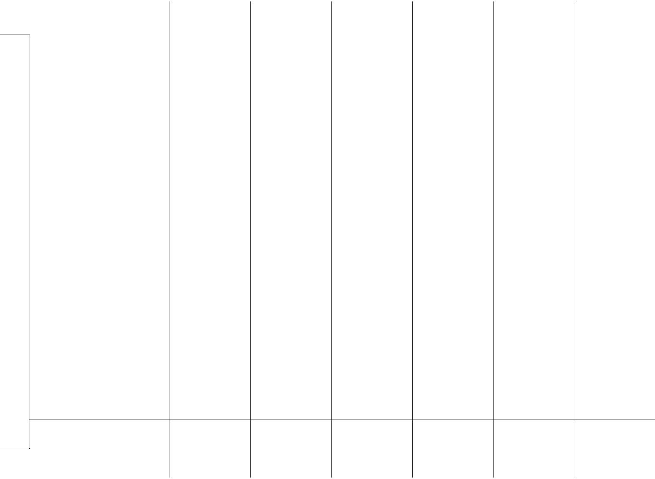

Other services | 3,2% | 12,6% |  | 62,1% | 15,0% | 7,1% | 100%
Total | 5,5% | 13,8% |  | 54,4% | 16,6% | 9,6% | 100%

- Electricity, gas, water, sewage and public cleaning

- Financial intermediation, insurance and pension funds and services

Table 5: Percentage of Gross Value Added (GVA) at basic prices, by region in 2010 (IBGE, 2012, pp. 22-23)

The activities that most impacted the GDP of 2010 were the transformation industry and public administration, health, education and social security (each one represents 16,2% of the GVA in the GDP), followed by other services (14,3%) and commerce (12,5%).

23

Brazil: An application of Porter’s Diamond and attractiveness analysis for French FDI

 |  |  |  | North | Northeast | Southeast |  | South
 |  | Agriculture | 9 718,13 |  | 16 686,08 | 29 110,23 | 24 811,76
 |  | Extractives | 10 074,87 |  | 4 058,05 | 38 739,42 | 779,90
 |  | Industry
 |  | Transformation | 14 181,93 |  | 27 700,84 | 179 380,70 | 62 396,17
 |  | Industry
 |  | Construction | 7 397,50 |  | 18 139,10 | 52 514,03 | 15 919,06
 |  | Production and
 |  | distribution of | 3 023,57 |  | 11 852,53 | 28 185,20 | 11 807,92
** |  | facilities ⁽¹⁾
** |  | Commerce | 11 045,34 |  | 36 446,62 | 118 031,57 | 44 794,35
Activities
Activities |  | Transport, storage | 3 673,02 |  | 10 836,69 | 54 668,24 | 16 540,49
 |  | and mail
 |  | Information | 1 486,20 |  | 4 907,51 | 41 290,61 | 7 067,56
 |  | Services
 |  | Finances ⁽²⁾ |  | 2 635,38 | 11 454,42 | 92 206,86 |  | 19 145,32
 |  | Real estate | 7 141,24 |  | 19 580,10 | 82 014,63 | 22 804,10
 |  | activities and rent
 |  | Management,
 |  | Health, Education | 22 939,10 |  | 58 710,47 | 119 029,76 | 39 739,44
 |  | and Social
 |  | Security
 |  | Other services | 8 350,40 |  | 33 169,63 | 163 209,39 | 39 384,32
 |  | Total | 101 666,69 |  | 253 542,04 | 998 380,62 | 305 190,40

* (in millions of US dollars)
⁽¹⁾ Electricity, gas, water, sewage and public cleaning
⁽²⁾ Financial intermediation, insurance and pension funds and services

Central-

West

- 971,03

849,15

- 963,87

- 750,47

4 172,13

- 319,79

- 326,06

- 348,68

- 343,83

- 164,48

56 727,55

- 612,70

- 549,74

Total


- 297,23

- 501,38

- 623,51

- 720,16

59 041,34

- 637,67

- 044,50

- 100,56

- 785,82

- 704,56

297 146,32

- 726,45

1 834 329,49

Table 6: Gross Value Added (GVA) at basic prices, by region in 2010 (Data Source: IBGE, Contas Regionais do Brasil, 2012)

Brazil has a vast diversity of activities and it varies according to the natural resources, geographic position, local needs and tax incentives by the States.

2.3.1 Brazilian Clusters

In this part some important clusters in each region of this country will be explored.

A cluster is a geographic proximate group of interconnected companies, service providers and associated institutions in a particular field (Porter, 2000, p. 15).

In general the clusters are the results of business-government collaboration. The local governments offer tax exemptions, infrastructure (for transportation, electricity, telecommunication) and local support (schools, public services, hospitals). Clusters develop

24

Brazil: An application of Porter’s Diamond and attractiveness analysis for French FDI

the cities and surrounding areas, attract qualified workforce, create a mutually support among the group of industries and encourages a pro-competitive behaviour.

Under mentioned is an overview of some important clusters and activities by region:

2.3.1.1 North Region:

Zona Franca de Manaus (Free Zone of Manaus) is a model of economic development, implemented by Brazilian government with the main goal to facilitate an economic basis in the Western Amazonia in order to promote a better productive and social integration in this region. The States belonging to it are Acre, Amazonas, Rondônia and Roraima and the cities Macapá and Santana (from Amapá State). Zona Franca de Manaus has three economic clusters: commercial, industrial and agribusiness. The industrial cluster has around 600 high-technology factories and generates more than 500.000 jobs, direct and indirect. The agribusiness’ segment has its activities on food production, agriculture, fisheries, tourism, wood processing and others².

Serra dos Carajás has the highest quality iron ore in the world. The Company Vale explores it. It is the biggest metal and mining company in the world. Vale’s mines covers 3% of the Carajás National Forest’s area. The railroads, airport and hydroelectric power station are part of the business to supply its demand³.

2.3.1.2 Northeast Region:

Porto Digital is a partnership among the private, public sectors and universities. Located in Recife (Pernambuco State), one of the most important cities of Brazil, it was founded in July 2000. This cluster has 200 institutions of information technology and communication, creative technology, specialised services and development agencies. In 2010, these companies achieved a revenue of 568 million US dollars⁴.

- Source: SUFRAMA, retrieved 10 26, 2013: http://www.suframa.gov.br/zfm_principal.cfm

- Source: VALE, retrieved 10 26, 2013: http://www.vale.com

- Source: Porto Digital, retrieved 10 26, 2013: http://www.portodigital.org

25

Brazil: An application of Porter’s Diamond and attractiveness analysis for French FDI

Camaçari Industrial Complex started its operation in 1978. It was the first planned petrochemical complex in Brazil. Located in Camaçari (Bahia State), is 50 kilometres far from Salvador, the capital of the State. It is composed of over than 90 chemical and petrochemical companies besides the production of cellulose, copper metallurgy, textiles, automobiles, beverages and services. It employs 30.000 people, directly and indirectly. Its total sales are around 15 billion US dollars per year⁵.

2.3.1.3 Southeast Region:

Resende Industrial Park (Rio de Janeiro State) is located in a strategic area bordering São Paulo State. This city is an industrial cluster and the main sectors presents are metal-mechanic and chemical-pharmaceutical (Prefeitura de Resende, 2013). The GDP of Resende in 2010 was of 3,6 billion US dollars (IBGE Cidades, 2010).

Campinas Cluster, in Campinas (São Paulo State) located 100 km from São Paulo city. The cluster has industries in different sectors such as automobile, textile, metallurgic, alimentary, petrochemical, pharmaceutical, telecommunications, electronics, information technology, fine chemicals, furniture, ceramic and others. It has a total of 6.478 industries, 14.027 services companies and 19.974 companies. Fifty of the 500 biggest companies in the world are in this area (Cendotec, 2005, p. 01). Campinas is a very important city in the Brazilian context and its GDP in 2010 was 20,8 billion US dollars (IBGE Cidades, 2010).

Embraer is the Brazilian aeronautic company, created in 1969 as a mixed capital company under government control. In 1994 Embraer was privatized and restructured. This company was founded with the support of Brazilian Government having the purpose to transform science and technology provided by the Institute of Aeronautic Technology (ITA) into engineering and industrial capability⁶. In 2012, its net income was 348 million US dollars.

- Source: Camaçari Industrial Development Committee, retrieved 10 26, 2013: http://www.coficpolo.com.br/

- Source: EMBRAER, retrieved 10 27, 2013: http://www.embraer.com.br/en-us/conhecaembraer/tradicaohistoria /pages/home.aspx

26

Brazil: An application of Porter’s Diamond and attractiveness analysis for French FDI

2.3.1.4 South Region:

Cluster electro-metal-mechanical, in the city of Joinville (Santa Catarina State) concentrates 2.038 industries employing 75.345 people in 2011 (FIESC, 2013, p. 143), in different sectors such as foundry, household appliances, plastic and technology. In 2010, Joinville had a GDP of 10,5 billion US dollars (IBGE Cidades, 2010).

Vale do Rio dos Sinos Footwear cluster, in Rio Grande do Sul State, is the aggregation of firms of 30 municipalities located around Sinos River. This cluster has the industries to supply the footwear chain: tannery and leather. In 2005, the footwear industry represented 23,5% of total employment in Rio Grande do Sul State (Costa, 2010, p. 162). The total of related industries are 1.745 of footwear industry and 675 of diverse industries as rubber, tobacco, leather and fur. The GDP in 2010 of Vale do Rio dos Sinos’ region was of 21,4 billion US dollars (ACI, 2013).

2.3.1.5 Central-West Region:

Nova Mutum, in Mato Grosso do Sul State, is a municipality whose main activities are in the primary sector of the economy (Prefeitura de Nova Mutum - MT, 2013). Its economic activities are: soya, corn, cotton, aviculture, cattle, swine, familiar agriculture, apiculture, milk production and viniculture. This is the third municipality of Brazil with a better human development index (HDI) and reference in tourism destination because of its sustainable technology in the agribusiness (Agronotícias, 2013).

Anápolis, in Goiás State, is an important agro-industrial cluster with 100 companies and a pharmaceutical cluster with 15 firms of medium and large scale⁷.

⁷ Source: ACIA (Associação Comercial e Industrial de Anápolis) retieved 10 28, 2013:

http://www.aciaanapolis.com.br/pagina.php?acao=pagina&id=17

27

Brazil: An application of Porter’s Diamond and attractiveness analysis for French FDI

All the Brazilian regions have clusters. Some are focused in the agribusiness, as Centre-Western, others with a mix of industries and activities. In general the cities that are the capital of State have large concentration of people, commerce and industries. The old model of clusters in Brazil was to have the industries around the big centres or its axes as São Paulo, Rio de Janeiro and Belo Horizonte. Nowadays, new clusters tend to be created in cities that do not have many industries. The local government offers incentives to develop new areas.

This decentralization may balance the employment and development of Brazilian regions, as well as the improvement of services that come together such as transportation, construction, telecommunication, education and basic sanitation.

28

Brazil: An application of Porter’s Diamond and attractiveness analysis for French FDI

3 Literature review

This section will approach the theory of country attractiveness and the model applied in the perspective of Brazil as a competitive advantage nation.

The attractiveness of a country can be measured in many ways. According to Philippe Lassere, a country is considered attractive when there are market and industries opportunities and it is acceptable in terms of risks for the employees and shareholders. These are the two generic points to be used as the logic of attractiveness. If the investor gets a return equal or higher than its risk adjusted weighted cost of capital, then, this country is considered attractive (Lasserre, 2003, pp. 156-157).

It is very difficult to do generalizations, however the country is analyzed in its entirety to give a general perception of its opportunities and risks. To refine the evaluation, the country is compared to another with similar features.

The decision to enter the foreign markets is made after a very diversified analysis, which aims to identify the country’s attractiveness followed by the implementation of the strategies chosen (entry mode, developing paths and organization control).

In the assessment of the country’s attractiveness, many factors have to be considered: size and growth, resources, incentives and risks. In terms of industry, the market and internal competition are important factors for companies interested in FDI.

The market and industry opportunities are measured by the potential demand and how easy it is to compete in the country. Brazil has a high internal demand in growth (also because of the middle-class effect), large availability of raw materials, innovation culture and investments incentives granted by the government.

The risks of a country affect differently the distinct market segments. There are many models and sources of countries’ assessment that compare the risks of countries. Below is a list of various rankings, showing the position of Brazil:

29

Brazil: An application of Porter’s Diamond and attractiveness analysis for French FDI

 | Publication/Institution | Type of ranking |  | Total of |  | Brazilian
 | Publication/Institution | Type of ranking |  | countries |  | Ranking
 | The World
 | Competitiveness | The World Competitiveness Scoreboard 2013 | 60 |  | 51
 | Yearbook⁸
 | IESE Insight⁹ | The Venture Capital and Private Equity Country | 118 |  | 36
 | IESE Insight⁹ | Attractiveness Index
 |  | Global of Competitiveness Index |  | 148 |  | 46
 | The World Economic
 | The World Economic | Basic Requirements |  | 148 |  | 79
 | Forum¹⁰
 | Forum¹⁰ | Efficiency enhancers |  | 148 |  | 44
 |  | Innovation and sophistication factors |  | 148 |  | 46
 | EY¹¹ | Renewable energy country attractiveness Index |  | 40 |  | 15

Table 7: Model and sources assessment for Brazil in 2013

Looking inside these rankings, the most important risks identified in Brazil are tax regulations and rates, corruption, supply of infrastructure and inefficient government bureaucracy.

Many theories and studies could be used and combined to help the decision of FDI, being the most common used the PESTEL, Porter’s five-forces framework, SWOT, Hofstede model, rankings and financial indicators analysis.

The focus of this paper is in the initial part of the decision-making process, i.e.: the analysis of attractiveness.

The theoretical framework chosen to be studied in this paper is the “Determinants of National Advantage”; also known as “National Diamond” or “Diamond of National Advantage”.

- Source: The World Competitiveness Center (WCC), retrieved 10 01, 2013: http://www.imd.org/wcc

- Alexander Groh, Heinrich Liechtenstein and Karsten Liese. The project was initiated at IESE Business School Barcelona in 2006 with a European pilot study. From the European study we gained experience and the confidence to extend the study globally. Source: retrieved10 02, 2013, http://blog.iese.edu/vcpeindex/ranking-2013/
- Source: The Global Competitiveness Report 2013-2014, retrieved 09 28, 2013:

http://www.weforum.org/reports/global-competitiveness-report-2013-2014

¹¹Source: EY, RECAI August 2013, retrieved 09 28, 2013: http://www.ey.com/Publication/vwLUAssets/Rene wable_energy_country_attractiveness_indices_-_Issue_38/$FILE/RECAI%20Issue%2038_August%202013.pdf

30

Brazil: An application of Porter’s Diamond and attractiveness analysis for French FDI

3.1 Diamond of National Advantage

The book “The Competitive Advantage of Nations” published in the 90s by Michael E. Porter opened a new view about the advantages of the countries. All the knowledge of previous studies and publications in the scope of companies has been adapted to the nations context.

“The principal goal of a nation is to produce a high and rising standard of living for its citizens.” – Michael E. Porter

Porter has applied his diamond theory in 8 countries (Germany, Italy, Japan, Korea, Sweden, Switzerland, the United Kingdom, and the United States). He also studied Denmark and Singapore that are not detailed in his book. His study was very precise and detailed and the most data collected are from the 70s.

The Diamond of National Advantage consists of four attributes that analysed individually or as a system are determinant to understand the advantage of a nation and identify how each nation establishes the playing field and operations on its industries.

Inside the nation it is important to exist competition amongst the industries. To be competitive and reach better results the industries will invest in researches and development, and as a consequence a high level of services and/or products are ensured giving the nation more advantage to stay competitive.

The attributes of the diamond help to understand the strengths and weakness of the nation in a determined region or industry. The attributes determined by Porter are the following: factor conditions, demand conditions, related and supporting industries and firm strategy. The government’s policies and chance are also contributing factors that have an impact in all the determinants of the diamond and they can be decisive for the success or not of the system.

The factors “Government” and “Chance” were considered later on in Porter’s analysis. The Government is a relevant factor and will be considered and explored in this paper while the factor chance will not be deeper considered once it is intangible and an unpredictable situation.

The Government plays an essential role of providing the right conditions and encouragement to the industries for the achievement of higher levels of competitive performance. It is

31

Brazil: An application of Porter’s Diamond and attractiveness analysis for French FDI

responsible for taking decisions in terms of legislations, internal procedures of commerce, monetary control (adapt the volume of means of payment to the real needs of the National economy, regulates the internal value of currency (Banco Central do Brasil, 1964, pp. 01-02)) and treaties with other countries or economical blocks that can be decisive for the internal industries.

Following is a brief explanation of the four attributes referred by Porter (The Competitive Advantage of Nations, 1990, pp. 73-110):

Factor Conditions are the aspects in terms of production such as infrastructure and specialized human resources. The factor conditions are in general created by the nations and not by the natural environment. The presence of raw material, for example, plays an important role in the competitive advantage of industries in the nation, but Porter defends that the factors conditions goes beyond it. If a nation is not endowed with natural resources, it can be found in other countries. It is not a problem that cannot be overcome.

Demand conditions are the demands of the internal market in terms of products and services. The home’s demand shapes the form of how the firms receive, interpret and responds to buyers’ needs.

Related and supporting industries refer to the existence or absence of suppliers and related industries internationally competitive.

Firm strategy, structure and rivalry are the national tendencies of how the companies are created, organized and managed in the country and how the intern rivalry is played.

32

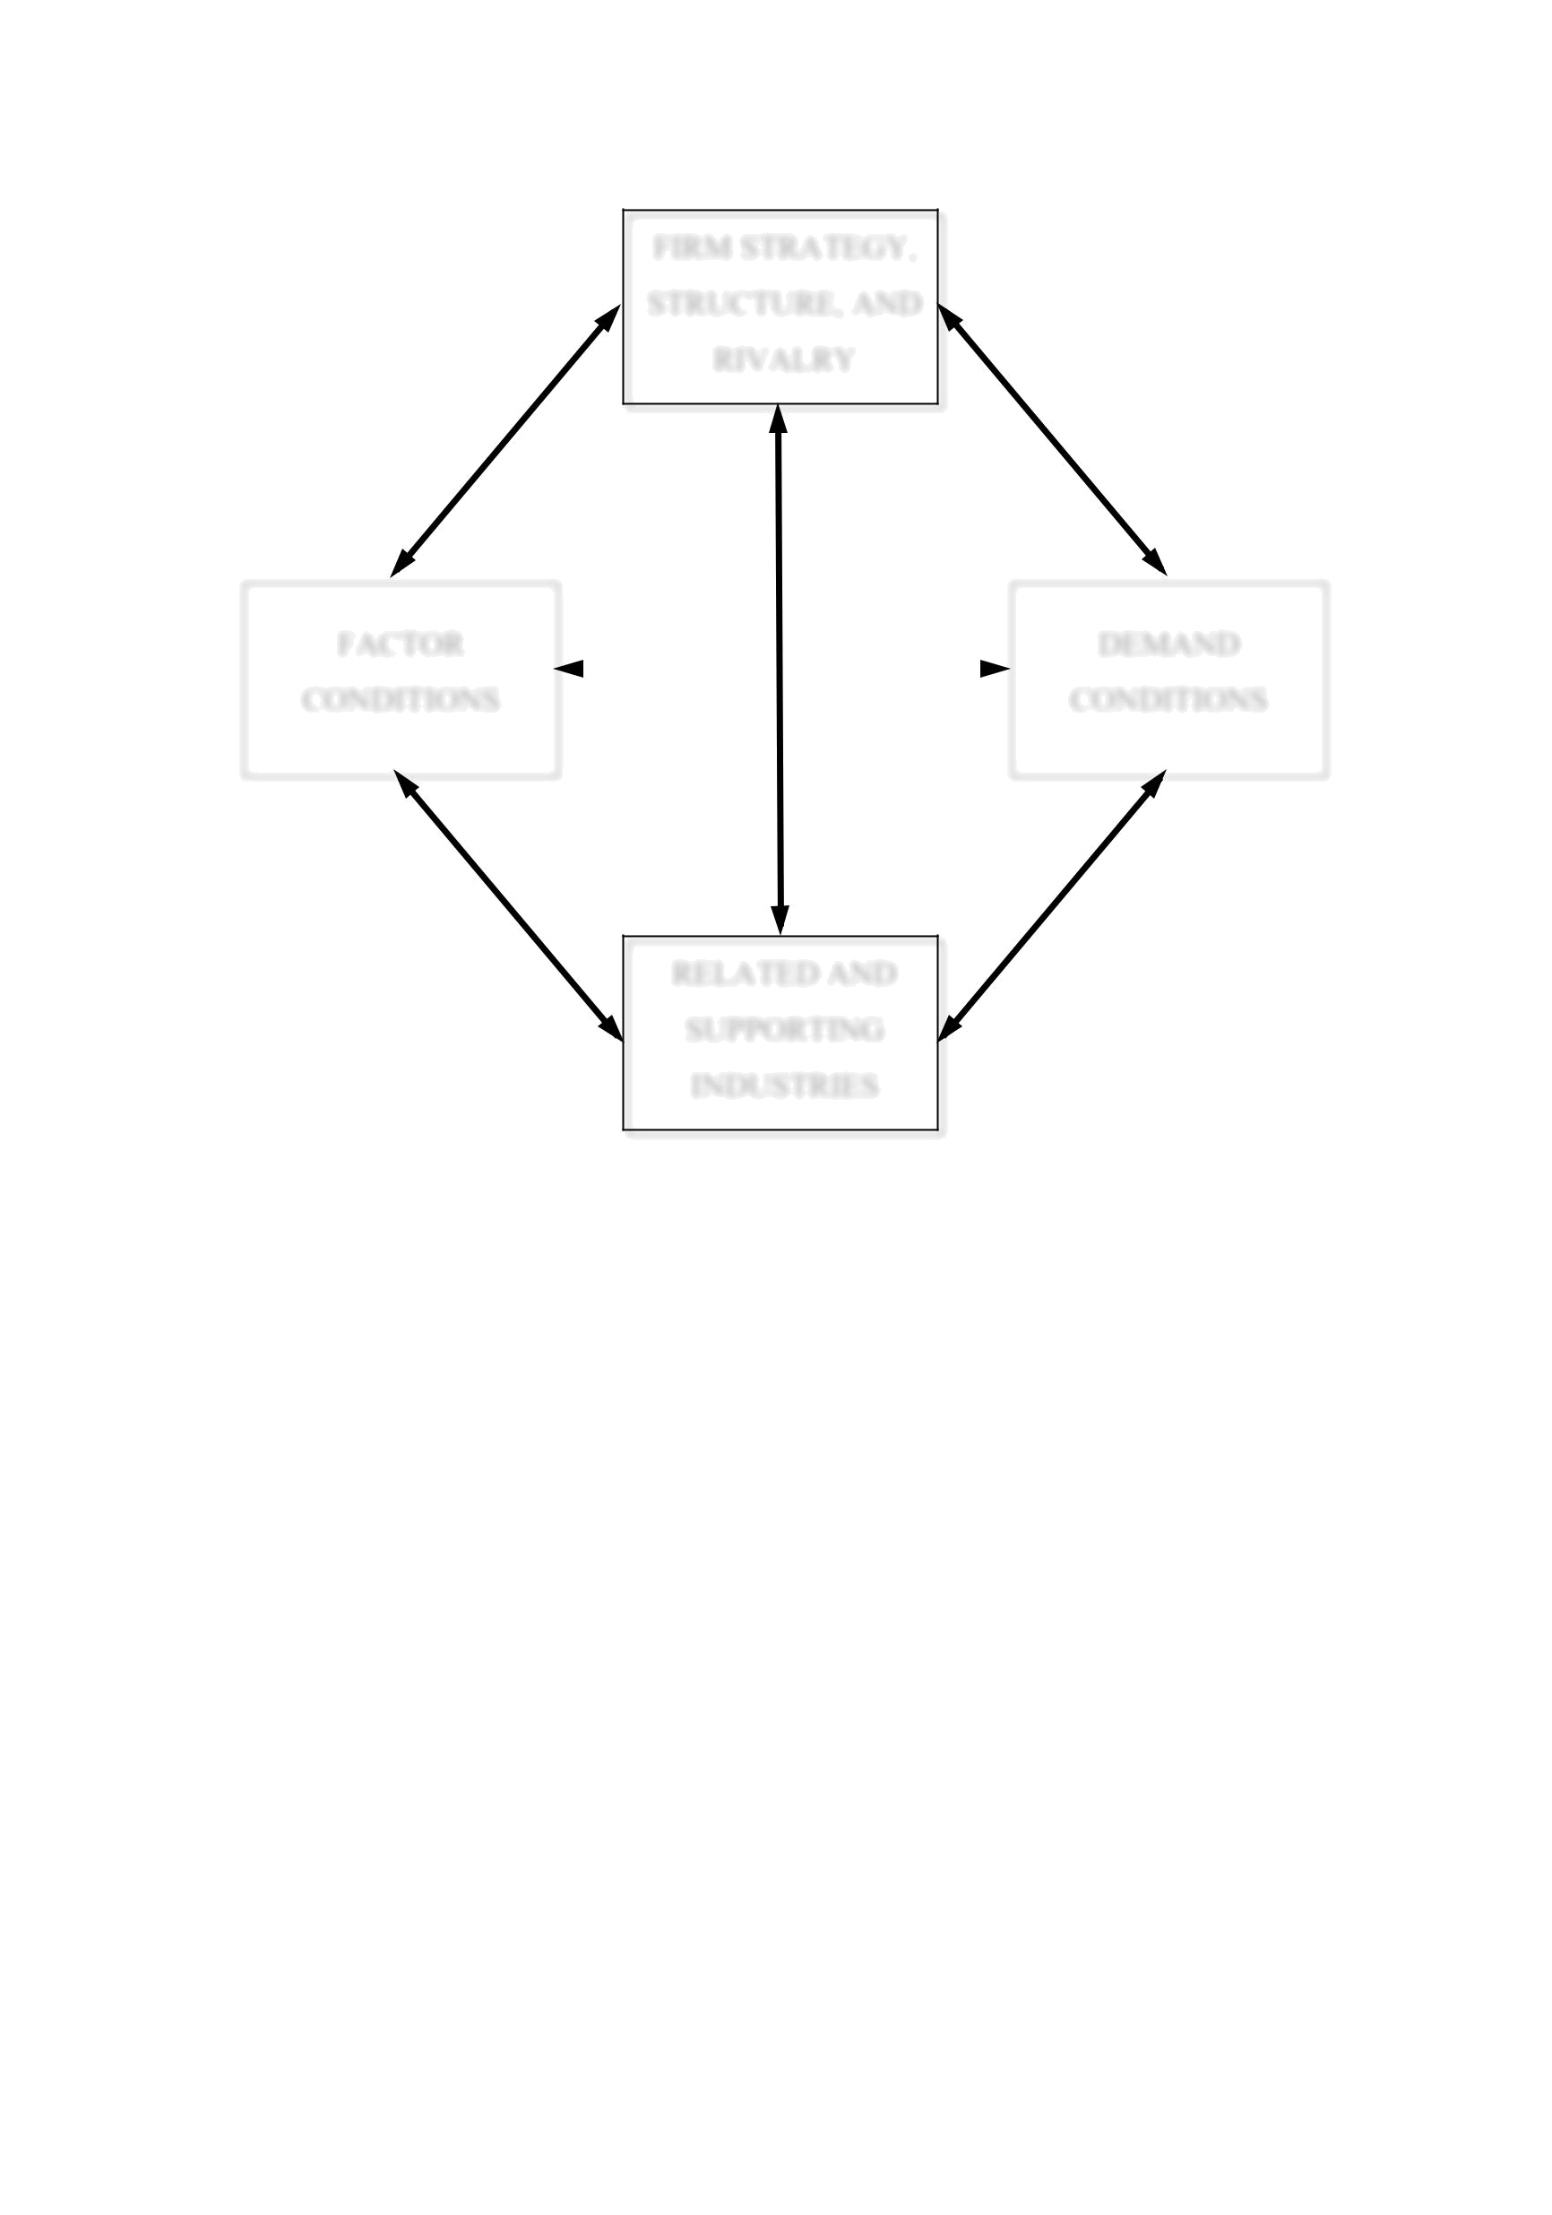
Brazil: An application of Porter’s Diamond and attractiveness analysis for French FDI

FIRM STRATEGY,

STRUCTURE, AND

RIVALRY

FACTOR |  |  |  | DEMAND
CONDITIONS |  |  |  | CONDITIONS

RELATED AND

SUPPORTING

INDUSTRIES

Figure 2: Reproduction of The Determinants of National Advantage (Porter, 1990, p. 72)

In the context of this paper, Brazil is the country to have its attributes reviewed. In this section a diamond’s analysis will be described in relation to this nation.

As explained before, Brazil has the characteristic of a country continent because of its dimension, different cultural and natural aspects. For these reasons, it is very difficult to generalize the country. The strengths and weakness of one region or city can be the opposite of others, even among neighbours, but it is still a single country. This study will exemplify by pointing a region or city, in case a need for a better understanding and analysis if necessary.

33

Brazil: An application of Porter’s Diamond and attractiveness analysis for French FDI

3.1.1 Industries classification

This section aims to explain the classification of goods and merchandises used in this paper. This classification is important to help the identification of the kind of industries that exports the most in Brazil and later will be classified into the cluster chart.

The industries in Brazil (and MERCOSUR) have a classification known as NCM (MERCOSUR Common Nomenclature). The first six digits presented in the code (each two represents: chapter, heading and subheading, respectively) follow the Harmonized System (HS) defined by the World Customs Organization, and the last two digits (item and sub-item), are created under the definition established between the MERCOSUR countries.

0 0 0 0 . 0 0 . 0 0
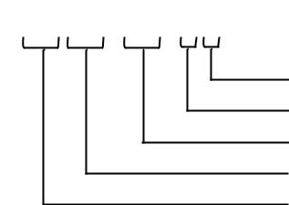

Sub-item | MERCOSUR digits
Item | MERCOSUR digits
Subheading | Harmonized System
Heading | Harmonized System
Chapter


Figure 3: Structure of MERCOSUR Common Nomenclature (adapted from MDIC, 1988)

The classification of goods in NCM is governed by the General Rules for the Interpretation of the Harmonized System (MDIC, 2013). For this paper’s purposes, the 4 first digits will be used because they will be enough for further analysis. These digits correspond to the “chapter” and “heading” of the Nomenclature, also identified by “HS4”. For this level of detail, that will be designated as “Industry”.

3.1.2 The patterns of Brazil competitive advantage

Based on Porter’s studies, the top fifty Brazilian industries will be analysed, in terms of share world exports.

To produce this final table, online tables from the International Trade Centre website were generated for the Brazilian’s exports and World’s imports and exports. The data are from year 2010. To validate the accurate data of those tables for the Brazilian’s imports and exports of the studied year, it was compared with data from Brazilian government (MDIC, 2010).

34

Brazil: An application of Porter’s Diamond and attractiveness analysis for French FDI

A difference was found between the sources, an export for the NCM HS4 9998 “Consumption on board (fuels and lubricants for ships and aircraft)”. The Brazilian government accounted 36.955,77 million US dollars, without imports registered for the same industry/period. In the calculations, this export represented 1,87% of the “Share of Total Brazilian Exports”. This item will not be added to the list of top fifty because it is not in the United Nations Statistics and its “chapter” 99 is used for “Commodities not specified according to kind” (UN comtrade, 2007).

Below the top fifty export for the Brazilian industries:

 |  |  | Industry
 | 1701 |  | Cane or beet sugar and chemically pure
 | 1701 |  | sucrose, in solid form
 | 2601 |  | Iron ores and concentrates, including roasted
 | 2601 |  | iron pyrites
 | 1201 |  | Soya beans, whether or not broken
 | 0207 |  | Meat and edible offal, of the poultry of
 | 0207 |  | heading No 0105, fresh, chilled or frozen
 | 8307 |  | Flexible tubing of base metal, with or
 | 8307 |  | without fittings
 | 2401 |  | Unmanufactured tobacco; tobacco refuse
 | 0202 |  | Meat of bovine animals, frozen
 |  |  | Coffee, whether or not roasted or
 | 0901 |  | decaffeinated; coffee husks and skins; coffee
 | 0901 |  | substitutes containing coffee in any
 |  |  | proportion
 | 2304 |  | Soybean oilcake and other solid residue,
 | 2304 |  | wh/not ground
 | 7201 |  | Pig iron and spiegeleisen in pigs, blocks or
 | 7201 |  | other primary forms
 | 8706 |  | Chassis, with engines, for vehicles of
 | 8706 |  | positions 87.01 through 87.05
 |  |  | Undenatured ethyl alcohol of an alcoholic
 | 2207 |  | strength by volume of 80 % vol or higher;
 | 2207 |  | ethyl alcohol and other spirits, denatured, of
 |  |  | any strength
 | 4703 |  | Chemical wood pulp, soda or sulphate, other
 | 4703 |  | than dissolving grades
 |  |  | Fruit juices (including grape must) and
 |  |  | vegetable juices, unfermented and not
 | 2009 |  | containing added spirit, whether or not
 |  |  | containing added sugar or other sweetening
 |  |  | matter
 | 1507 |  | Soya-bean oil and its fractions, whether or
 | 1507 |  | not refined, but not chemically modified
 |  |  | Tanned or crust hides and skins of bovine
 | 4104 |  | (including buffalo) or equine animals,
 | 4104 |  | without hair on, whether or not split, but not
 |  |  | further prepared
 | 2818 |  | Artificial corundum, whether or not

Share of |  |  |  |  |  | Share of
Total |  | Export |  | Import |  | Total
World |  | Value * |  | Value * |  | Brazilian
Exports |  |  |  |  |  | Exports
43,06 | 12 761,41 |  | 3,50 |  | 6,47
27,91 | 28 911,88 |  | 138,01 |  | 14,65
27,76 |  | 11 043,00 |  | 435,59 |  | 5,60
27,59 | 5 952,03 |  | 30,53 |  | 3,02
25,91 | 649,31 |  | 665,84 |  | 0,33
24,98 |  | 2 706,67 |  | 679,82 |  | 1,37
23,13 |  | 3 376,28 |  | 648,27 |  | 1,71
21,42 | 5 203,35 |  | 215,18 |  | 2,64
21,16 | 4 719,37 |  | 128,74 |  | 2,39
20,20 | 971,14 |  | 3,52 |  | 0,49
17,82 | 635,60 |  | 177,24 |  | 0,32
16,86 | 1 014,29 |  | 413,22 |  | 0,51
16,33 | 4 434,24 |  | 3 251,04 |  | 2,25
14,43 | 1 924,69 |  | 276,41 |  | 0,98
13,83 | 1 347,66 |  | 139,37 |  | 0,68
13,50 | 736,58 |  | 397,14 |  | 0,37
13,04 |  | 1 774,39 |  | 501,94 |  | 0,90

35

Brazil: An application of Porter’s Diamond and attractiveness analysis for French FDI


1602

1005

4107

0102

7207

7202

6802

5201

0203

8802

4802

8429

8701

2603

7601

8409

6403

4011

3901

8704

8407

8501

8414

2709

chemically defined; aluminium oxide; aluminium hydroxide

Other prepared or preserved meat, meat offal or blood

Maize (corn)

Leather further prepared after tanning or crusting, including parchment-dressed leather, of bovine (including buffalo) or equine animals, without hair on, whether or not split, other than leather of heading 4114

Live bovine animals

Semi-finished products of iron or non-alloy steel

Ferro-alloys

Worked monumental or building stone (except slate) and articles thereof, other than goods of heading 6801; mosaic cubes and the like, of natural stone (including slate), whether or not on a backing; artificially coloured granules, chippings and powder, of

Cotton, not carded or combed

Meat of swine, fresh, chilled or frozen

Other aircraft (for example, helicopters, aeroplanes); spacecraft (including satellites) and suborbital and spacecraft launch vehicles

Uncoated paper and paperboard, of a kind used for writing, printing or other graphic purposes, and non-perforated punch-cards and punch tape paper, in rolls or rectangular (including square) sheets, of any size, other than paper of heading No 4801 or 4803

Self-propelled bulldozers, angledozers, graders, levellers, scrapers, mechanical shovels, excavators, shovel loaders, tamping machines and road rollers

Tractors (other than tractors of heading 8709)

Copper ores and concentrates Unwrought aluminium

Parts suitable for use solely or principally with the engines of heading No 8407 or 8408

Footwear with outer soles of rubber, plastics, leather or composition leather and uppers of leather

New pneumatic tyres, of rubber

Polymers of ethylene, in primary forms

Motor vehicles for the transport of goods

Spark-ignition reciprocating or rotary internal combustion piston engines

Electric motors and generators (excluding generating sets)

Air or vacuum pumps, air or other gas compressors and fans; ventilating or recycling hoods incorporating a fan, whether or not fitted with filters

Crude oil from petroleum and bituminous minerals

10,37 | 1 268,18 |  | 33,75 |  | 0,64
9,50 |  | 2 214,96 |  | 759,78 |  | 1,12
9,06 | 982,53 |  | 70,49 |  | 0,50
8,79 |  | 658,66 |  | 45,00 |  | 0,33
8,27 | 2 434,34 |  | 224,63 |  | 1,23
7,58 |  | 2 038,95 |  | 2 513,75 |  | 1,03
6,26 | 633,16 |  | 393,22 |  | 0,32
5,48 |  | 821,55 |  | 683,05 |  | 0,42
4,90 |  | 1 226,58 |  | 0,91 |  | 0,62
4,63 | 3 999,05 |  | 10 806,30 |  | 2,03

4,14 934,19 2 132,97 0,47

3,66 | 1 349,69 |  | 8 411,85 |  | 0,68
2,84 | 1 047,87 |  | 1 233,30 |  | 0,53
2,75 |  | 1 237,74 |  | 9 654,49 |  | 0,63
2,74 |  | 1 280,35 |  | 1 322,01 |  | 0,65
2,58 | 1 446,94 |  | 12 238,97 |  | 0,73
2,02 | 924,30 |  | 809,40 |  | 0,47
1,91 |  | 1 277,12 |  | 12 867,16 |  | 0,65
1,82 |  | 1 113,05 |  | 9 982,20 |  | 0,56
1,81 |  | 1 686,89 |  | 19 775,19 |  | 0,85
1,81 | 641,37 |  | 4 383,61 |  | 0,32
1,79 | 721,84 |  | 5 912,87 |  | 0,37
1,53 | 932,22 |  | 14 070,30 |  | 0,47
1,44 | 16 293,42 |  | 100 974,46 |  | 8,26

36

Brazil: An application of Porter’s Diamond and attractiveness analysis for French FDI


 |  | Flat-rolled products of iron or non-alloy
7208 |  | steel, of a width of 600 mm or more, hot-
 |  | rolled, not clad, plated or coated
 |  | Gold (including gold plated with platinum),
7108 |  | unwrought or in semi-manufactured forms,
 |  | or in powder form
8708 |  | Parts and accessories of the motor vehicles
8708 |  | of heading 8701 to 8705
9403 |  | Other furniture and parts thereof
 |  | Taps, cocks, valves and similar appliances
8481 |  | for pipes, boiler shells, tanks, vats or the
8481 |  | like, including pressure-reducing valves and
 |  | thermostatically controlled valves
 |  | Motor cars and other motor vehicles
8703 |  | principally designed for the transport of
8703 |  | persons (other than those of heading 8702),
 |  | including station wagons and racing cars
 |  | Petroleum oils and oils obtained from
 |  | bituminous minerals, other than crude;
 |  | preparations not elsewhere specified or
2710 |  | included, containing by weight 70 % or
 |  | more of petroleum oils or of oils obtained
 |  | from bituminous minerals, these oils being
 |  | the basic con
 |  | Electrical apparatus for line telephony or
 |  | line telegraphy, including line telephone sets
8517 |  | with cordless handsets and
8517 |  | telecommunication apparatus for carrier-
 |  | current line systems or for digital line
 |  | systems; videophones
 |  | Medicaments (excluding goods of
 |  | heading 3002, 3005 or 3006) consisting of
 |  | mixed or unmixed products for therapeutic
3004 |  | or prophylactic uses, put up in measured
 |  | doses (including those in the form of
 |  | transdermal administration systems) or in
 |  | forms or packing
Total

* (in millions of US dollars)

1,38 |  | 770,17 |  | 9 481,39 |  | 0,39
1,26 |  | 1 801,95 |  | 22,52 |  | 0,91
1,16 |  | 3 381,64 |  | 49 285,00 |  | 1,71
0,89 |  |  | 582,28 |  | 863,43 |  | 0,30
0,88 |  | 576,00 |  | 10 577,97 |  | 0,29
0,79 |  | 4 416,14 |  | 83 049,81 |  | 2,24
0,45 |  | 3 060,74 |  | 111 258,56 |  | 1,55
0,39 |  | 1 277,74 |  | 33 594,31 |  | 0,65
0,29 |  | 898,05 |  | 31 449,41 |  | 0,46
 | 1,31 |  |  |  |  |  |  | 77,06

Table 8: Top Fifty Brazilian’s Industries in Terms of World Export Share, 2010 (elaborated

by the author, Data Source: International Trade Centre, Products, 2010)

The services also have a considerable impact in the inputs and outputs of the economy. They

are classified according to an internationally agreed framework for the compilation and

reporting of statistics of international trade in services (International Trade in Services, 2010,

p. 14):

37

Brazil: An application of Porter’s Diamond and attractiveness analysis for French FDI

 |  |  |  | Share of |  |  |  |  |  | Share of
 |  |  |  | Total |  | Export |  | Import |  | Total
 |  | Service |  | Service |  | Export |  | Import |  | Service
 |  | Service |  | Service |  | Value * |  | Value * |  | Service
 |  |  |  | World |  | Value * |  | Value * |  | Brazilian
 |  |  |  | Exports** |  |  |  |  |  | Exports
0268 |  | Other business services |  | 1,63 |  | 15 776,50 |  | 20 873,50 |  | 49,58
0236 |  | Travel |  | 0,62 |  | 5 918,85 |  | 16 421,70 |  | 18,60
0205 |  | Transportation |  | 0,62 |  | 4 931,37 |  | 11 338,70 |  | 15,50
0260 |  | Financial services |  | 0,75 |  | 2 072,62 |  | 1 678,87 |  | 6,51
0291 |  | Government services, n.i.e. |  | 2,29 |  | 1 526,90 |  | 2 845,75 |  | 4,80
0245 |  | Communications services |  | 0,47 |  | 435,00 |  | 271,16 |  | 1,37
0253 |  | Insurance services |  | 0,43 |  | 416,03 |  | 1 528,76 |  | 1,31
0266 |  | Royalties and license fees |  | 0,16 |  | 397,21 |  | 2 850,25 |  | 1,25
0262 |  | Computer and information services |  | 0,10 |  | 209,84 |  | 3 505,43 |  | 0,66
0287 |  | Personal, cultural and recreational services |  | 0,35 |  | 108,26 |  | 1 271,47 |  | 0,34
0249 |  | Construction services |  | 0,03 |  | 28,54 |  | 6,48 |  | 0,09
Total |  |  | 0,83 |  |  |  |  |  | 100,00
- (in millions of US dollars)

- The World Total Exported services has missing data from some countries

Table 9: Brazilian Services in Terms of World Export Share, 2010 (elaborated by the author,

Data Source: International Trade Centre, Services, 2010)

The result found in the top fifty illustrates how important the natural resources are to Brazil, not only one kind of product but in a diversified range as sugar cane, iron, soya beans, tobacco and coffee. All those had more than 20% each in terms of share of total world exports that represents a significant number.

In 2010, according to Center for Advanced Studies for Applied Economics, the agriculture represented 21% of Brazil’s GDP. The important exports in the same period for some products reveals the international competitive advantage of this nation in this area.

On a services’ perspective, the nation’s share of total world exports is very low, what can be explained by the high internal demand, and confirmed by a very high importation of services. Moreover, the exports of all services (31 billion US dollars) represented a high share of total Brazilian’s export (228 billion US dollars).

The top fifty reveals the importance of the main products exported and how concentrate it is, since it represents more than 75% of share of total Brazilian exports.

38

Brazil: An application of Porter’s Diamond and attractiveness analysis for French FDI

Following Porter’ study, in order to summarize the top fifty list, the structure of broad cluster will be adapted to the representation of the share of Brazilian’s exports. The products in the list were aggregated in the level of the “chapter”, defined by the Harmonized System (HS), and organized into the clusters (see Figure 4: The Cluster Chart). For some kind of products as “Live animals”, in this paper the classification will be in a different way from Porter’s: “Multiple business” instead of “Food/Beverage”. The services are aggregated in a cluster with the same name.

The broad cluster will be classified in three levels:

Upstream industries: its primary products are inputs to products in other industries.

Industrial and Supporting Functions: related to particular end uses and transformation industry.

Final Consumption goods: end-user sectors (also has primary products that are inputs in other industries, as example “Foods/Beverages” are the soya beans, that can be at the same time to the final user or can be processed into a derivated product).


 | Materials/ |  | Forest Products |  | Petroleum/ |  |  |  |  |  |  |  | Upstream Industries
 | Metals |  | Forest Products |  | Chemicals
 |  |  |  |  |  |  |  |  |  |  |  |  | Industrial and
 | Multiple |  | Transportation |  |  |  |  |  |  |  |  |  | Industrial and
 | Multiple |  | Transportation |  |  |  |  |  |  |  |  |  | Supporting
 | Business |  | Transportation |  |  |  |  |  |  |  |  |  | Supporting
 | Business |  |  |  |  |  |  |  |  |  |  |  | Functions
 |  |  |  |  |  |  |  |  |  |  |  |  | Final Consumption
 | Food/ |  | Textiles/ |  | Housing/ |  | Health Care |  | Personal |  | Services |  | Final Consumption
 | Beverage |  | Apparel |  | Household |  | Health Care |  | Personal |  | Services |  | Goods and Services

Figure 4: The Cluster Chart (adapted from Porter, 1990, p. 288)

The list of Brazilian exports was classified according to the Cluster Chart and the result is a clear overview of the nation in terms of competitiveness and its competitive sectors.

39

Brazil: An application of Porter’s Diamond and attractiveness analysis for French FDI

The clusters chart has the broad clusters and its level. Below in each cluster are identified the total share of Brazilian Exports and the percentage it represents in terms of World Exports.
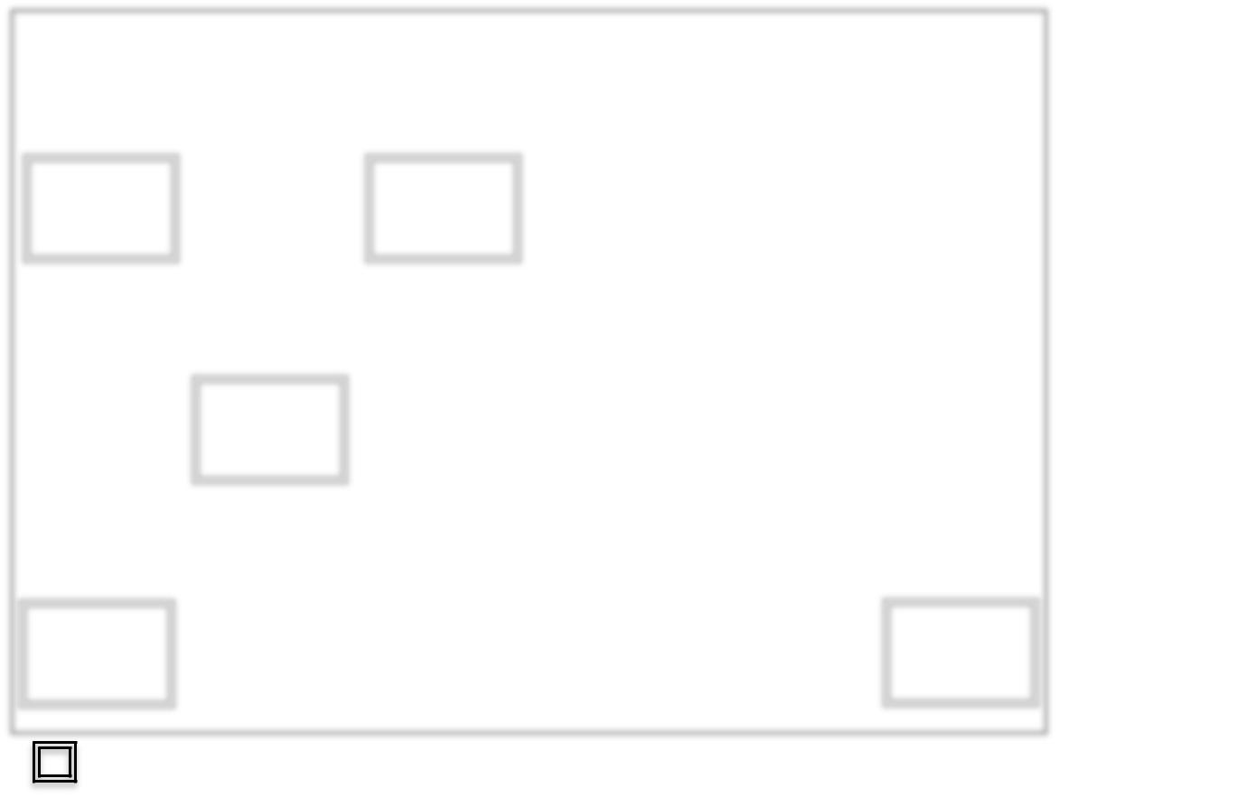

 |  | Materials/ |  |  |  | Forest |  |  |  | Petroleum/ |  |  |  |  |  |  |  |  |  |  |  |  |  | UPSTREAM
 |  | Metals |  |  |  | Products |  |  |  | Chemicals |  |  |  |  |  |  |  |  |  |  |  |  |  | INDUSTRIES
 |  |  |  |  |  |  |  |  |  |  |  |  |  |  |  |  |  |  |  |  |  |  |  | Brazil: | 34,63
 |  | Brazil: | 20,64 |  |  | Brazil: | 0,47 |  |  | Brazil: | 13,52 |  |  |  |  |  |  |  |  |  |  |  |  | World: | 2,84
 |  | World: | 8,70 |  |  | World: | 4,14 |  |  | World: | 1,39 |  |  |  |  |  |  |  |  |  |  |  |  | World: | 2,84
 |  |  |  |  |  |  |  |  |  |  |  |  |  |  |  |  |  |  |  |  |  |  |  | INDUSTRIAL AND
 |  | Multiple |  |  |  | Transpor-
 |  | Business |  |  |  | tation |  |  |  |  |  |  |  |  |  |  |  |  |  |  |  |  |  | SUPPORTING
 |  |  |  |  |  |  |  |  |  |  |  |  |  |  |  |  |  |  |  |  |  |  |  | FUNCTIONS
 |  | Brazil: | 4,38
 |  | Brazil: | 4,38 |  |  | Brazil: | 7,80 |  |  |  |  |  |  |  |  |  |  |  |  |  |  |  |  | Brazil: | 12,19
 |  | World: | 1,30 |  |  | World: | 1,40 |  |  |  |  |  |  |  |  |  |  |  |  |  |  |  |  | Brazil: | 12,19
 |  | World: | 1,30 |  |  | World: | 1,40 |  |  |  |  |  |  |  |  |  |  |  |  |  |  |  |  | World: | 1,37
 |  |  |  |  |  |  |  |  |  |  |  |  |  |  |  |  |  |  |  |  |  |  |  | FINAL
 |  | Food/ |  |  |  | Textiles/ |  |  |  | Housing/ |  |  |  | Health Care |  |  | Personal |  |  |  | Services |  |  | FINAL
 |  |  |  |  |  |  |  |  |  |  |  |  |  |  |  |  |  |  |  |  |  |  |  | CONSUMPTION
 |  | Beverage |  |  |  | Apparel |  |  |  | Household
 |  |  |  |  |  |  |  |  |  |  |  |  |  |  |  |  |  |  |  |  |  |  |  | GOODS AND
 |  |  |  |  |  | Brazil: | 1,76 |  |  | Brazil: | 0,30 |  |  | Brazil: | 0,46 |  | Brazil: | 1,37
 |  | Brazil: | 26,37 |  |  | Brazil: | 1,76 |  |  | Brazil: | 0,30 |  |  | Brazil: | 0,46 |  | Brazil: | 1,37 |  |  | Brazil: | 16,12 |  | SERVICES
 |  | World: | 21,52 |  |  | World: | 4,50 |  |  | World: | 0,89 |  |  | World: | 0,29 |  | World: | 24,98 |  |  | World: | 0,83
 |  | World: | 21,52 |  |  | World: | 4,50 |  |  | World: | 0,89 |  |  | World: | 0,29 |  | World: | 24,98 |  |  | World: | 0,83 |  | Brazil: | 46,38
 |  |  |  |  |  |  |  |  |  |  |  |  |  |  |  |  |  |  |  |  |  |  |  | World: | 2,01

Broad sectors in which Brazil’s international competitive positions are related

Figure 5: Share of Exports of the World and Brazil by Cluster, in 2010

(elaborated by the author)

The selected clusters identified as board clusters are the international competitive Brazilian industries. They are grouped in five clusters and they are most concentrated in upstream industries and final consumption goods and services. This last represents almost half of total of Brazil’s exports, which stands the highly international competitive industries.

The largest industry in terms of Brazil’s exports is the food and beverage. It represents more than 26% of total nation’s exports. The second cluster is the materials and metals and represents 20% of total nation’s exports. The third is the cluster of petroleum and chemicals, which represents more than 13% of total nation’s exports. The fourth cluster has all services and it represents 16% of total exports.

The cluster level of industrial and support industry is not so competitive as the others, but still has an important value. At this level, there is the fifth cluster, i.e.: Transportation. Motorcars,

40

Brazil: An application of Porter’s Diamond and attractiveness analysis for French FDI

parts and accessories of motor vehicles are very competitive industries in Latin America market and aircraft industry in the world.

The clusters reinforce the results of the top fifty indicating that the natural resources are the international competitive advantage of Brazil, followed by transportation, represented by the automotive and aircrafts sectors. The services’ clusters, in a more detailed level, are mostly represented by architectural, engineering and other technical consultancy added by other business and legal, accounting, management and public relations services.

Some clusters have a high participation in the Worlds Export Share but it is not so representative in Brazilian Exports shares, therefore they will not be selected.

The Brazilian clusters illustrate the sectors of Brazil’s strength and the areas that the nation is internationally competitive.

3.1.3 Factor Conditions

This part of the study presents, in a general way, the nation’s factors input conditions, which are the natural and human resources and infrastructure.

Brazil’s international competitive industries gravitate around its natural resources associated to its climate, soil and the magnificence of this country.

Besides the Amazon forest, Brazil has a huge forest range in addition to some areas that are undergoing reforestation. Brazil has one of the most extensive river systems with 8 basins. The hydropower potential of those rivers are 260 GW and only 25% are being used in the energy production (Brazilian Electricity Regulatory Agence, 2003).

The plantation area is largely developed as well the areas for livestock production.

The technology for agriculture is highly developed and receives large investments by the government, private companies and producers operating in this area.

In terms of infrastructure, Brazil has many points to be improved specially the sector of internal transportation. However, in the last years both attention and investments have been rising towards this sector.

41

Brazil: An application of Porter’s Diamond and attractiveness analysis for French FDI

The country will host two big international events in the near future, namely: the next Football World Cup, in 2014, and the Olympic games, in Rio de Janeiro, in 2016. These two great events are one of the main reasons for many investments to be encouraged and funded by the Brazilian government.

The education in Brazil has received more attention by the Government in terms of investments. It is still a key factor to be improved in Brazil as the level of education is related to the social-economic conditions. The expected years of education is 16,3 between the ages of 5 and 39, which is close to the average of the OECD. Amongst adults between 25 to 64 years old, only 41% studied up to high school level. The positive point is that in the adult population between 25 to 34 years old, 53% have finished the high school (OECD, 2013).

The higher education receives more attention than elementary school in terms of public investment, but it is not accessible for all. In most cases, students who had a good basic and elementary school education are those who reach public higher education although the social-economic condition is also a strong determinant.

In Brazil the public education is free of charge. The government implemented a program of social and racial quotas. This program aims to reserves a percentage of places in the universities for students coming from public education, low income families and also for those that are self declared black, mixed race and indigenous. The racial quotas percentage varies per State and follows the recent census done by IBGE. This program was created to reduce the disparity of races in the public universities. The last census showed that 52% of the Brazilian population are self declared black, mixed race or indigenous, but nonetheless they represent less than 30% of the university students (Governo Federal do Brasil, 2012).

In terms of world rankings, the Brazilian universities have a lot to improve. In 2012/2013 Times Higher Education ranking, Brazil had only one University in the Top 200 and in 2013/2014 it drops out from the Top 200’ list (Times Higher Education, 2013).

Despite the fact that the universities of Brazil are not well rated in the world higher education rankings, it is well rated and highly respected by the Latin America community (Top Universities, 2013). As mentioned earlier in this paper, the technological clusters are closely important to the Universities for its contribution for the improvement of the quality,

42

Brazil: An application of Porter’s Diamond and attractiveness analysis for French FDI

investments and visibility it lends to the Universities thus allowing the attraction of more partners, which in turn generates employment to young graduates.

The foreign language proficiency is not a strength point in Brazil. Researches place Brazil in 46th position among 54 countries, with the level “very low” in English proficiency (Exame, 2012). The lack of a foreign language proficiency is a barrier for the Brazilian workers and companies. Generally speaking, the foreigners’ workers and companies have to learn Portuguese in order to achieve their goals or they will always depend on the fewer bilinguals’ employees. This factor condition should be better explored and could receive more attention from companies and educational entities. It can be overtaken by persistent endeavour and commitment. Since 1998 the teaching of English is mandatory from the fifth year of primary school. It means that all students in Brazil should have English classes and most have it, however it seems not to be enough in terms of quality and/or rigour.

The Portuguese language is a competitive advantage when doing business with other Portuguese speaking countries and administrative region such as Portugal, Angola, Cape Verde, Guinea-Bissau, Mozambique, São Tomé and Príncipe, Macau and East Timor.

The Brazilian working law regulation has come into practice since 1943. A normal working week is of 44 hours/week, from Monday to Saturday, exchangeable to Monday to Friday. The benefits of an employee are approximately 30 days of paid vacation with a bonus of 1/3 of the monthly salary (after a full year of employment), plus a bonus called “13th salary” in the end of the year. There are other benefits for overtimes, weekend works, night workers, and others according to the industry or work conditions. The costs of hiring an employee are high. The charges vary from segment of company, but in general, it represents 66% of the salaries (Deloitte, 2010). The minimum salary referenced in October 2013 is 678 Brazilian Real (313 US dollars).

43

Brazil: An application of Porter’s Diamond and attractiveness analysis for French FDI

3.1.4 Demand Conditions

This part presents the customer needs and market demands of the nation.

The internal demand in Brazil is huge thanks to its large demographic situation.

After many social programs to reduce the poverty and income inequality, a new kind of consumer has appeared in this nation. Those who lived close to the poverty line, use the aid provided by the government for basic needs such as food, school supplies, personal hygiene and clothing for the children (The World Bank, 2010).

For other families, before the aid they used their meagre budget to buy items of basic necessities leaving them with no money left till the end of the month. However this has changed. Now they have extra money that gives them purchasing power allowing the purchase of goods that formerly they were not able to. They are called “the new middle-class”.

In 1992, the middle-class, also known as “C class”, was composed by 34,96% of the population. In 2009, it turned into 50,5% and in 2010 it corresponded to 52% of the population. Nowadays they hold 46,24% of the purchase power (Secretária de Assuntos Estratégicos, 2013) and in the president’s election of 2014 they will represent 57% of the electorate (InfoMoney, 2011).

The considered middle-classes are the families having a total income between 486 and 2.097 US dollars, which is considered a medium income.

To contextualize, the “D classes” are the families that the total income is between 350 and 486 US dollars; the “E classes” have a total income below 350 US dollars and the “classes AB” have a total income higher than 2.097 US dollars. These data are used as reference for researches and varies one to another institute (Fundação Getúlio Vargas, 2013).

The improvement of life quality and incomes of the families is not only because of the aid’s programs. The considerable changes introduced in the Brazilian economy, the control of inflation and investments in the local market has reflected in prices stabilization. Brazilians are travelling more to other countries, seeing others cultures and habits and they are becoming more demanding and sophisticated in their taste.

44

Brazil: An application of Porter’s Diamond and attractiveness analysis for French FDI

The companies’ strategies have been changing in Brazil to follow the new market tendencies of these new customers that want to satisfy their personal wills. At this moment, the new consumption wave of the middle-class generates a great opportunity to enter the Brazilian market since the demand and exigencies are growing.

The Brazilian Government has a protective policy for the Brazilian businesses. The imports taxes are quite high for manufactured goods. In one hand it helps the local producers but in the other hand the consumer pays a higher price and sometimes does not have a high quality product comparing to the price paid (because of lack of competition).

The solution of many international industries in Brazil is to produce the merchandise in the country. A common example is the automobile industry. They carry their brand, but many cars have special designs and models for the Brazilian market and even the cars with the same name do not have the same characteristics in terms of parts and quality, except for the similar design in the case of the most popular models.

On Table 9: Brazilian Services in Terms of World Export Share, 2010, is another demand condition that requires additional attention. The report referenced evidences that Brazil imports more services than exports in many segments (except in Financial, Communication and Construction services). In a deeper analysis, the higher gaps are in operational leasing services, personal travel, computer services, air transport (passenger) and sea transport (freight).

For personal travel and air transport the exports could be improved with investments in tourism, as Brazil does not take as much advantage as it should of its immense potential. An important demand condition is the shortage of infrastructure such as hotels, transportation, touristic information and travel guides (in many languages). Other important factor of this demand is the upcoming international events that will take place in Brazil.

3.1.5 Related and Supporting Industries

This part unfolds the capability of local suppliers and the presence of clusters in the nation.

Related and supporting industries are very common in Brazil. This is easily justifiable by the great distances and the cost of transportation. The local governments and administration

45

Brazil: An application of Porter’s Diamond and attractiveness analysis for French FDI

usually offers tax exemption and other incentives for industries to develop the region and create employment.

In Camaçari, State of Bahia, the Camaçari Industrial Complex has the assembly factory of Ford since 2001 (the North-American company is present in Brazil since 1919, and was the first assembly factory in the country) and JAC (the Chinese company) schedule to be opening in 2014¹². The Industrial Complex has the support industries of tires (Continental and Bridgestone Firestone), automotive spare parts, polycarbonates and chemical industries for automotive supplies, services firms for industry maintenance, environmental protection, technological and others¹³.

This is one example as Brazil has automotive municipalities in other parts of the country, as ABC Region (Ford, General Motors, Mercedes-Benz and Scania), Piracicaba (Hiundai), Itirapina (Honda) Sorocaba (Toyota), Taubaté (Wolkswagen), all these are in São Paulo State. Anápolis (Hiundai) in Goiás State, São José dos Pinhais (Renault) in Paraná State, Porto Real (Peugeout and Citroen) in Rio de Janeiro State, Betin (Fiat) in Minas Gerais State, Fortaleza (Troller, Group Ford) in Ceará State, Caxias do Sul (Marcopolo) in Rio Grande do Sul State.

The cycles and motorcycle cluster is in the Zona Franca de Manaus. The motorcycle producers are Harley Davidson, Duas Rodas, Kasinski, Agrale and the Japanese Kawasaki, Honda, Suzuki and Yamaha. For bicycles production there are Caloi, Monark, Prince and CBB (Sundown Bike). They also have the suppliers and support industries in the cluster¹⁴.

The Institute of Aeronautic Technology (ITA) is a federal government institution dedicated to provide high-level education and research in Science and Technology, areas of interest to the aerospace sector. This institute is one of the best universities in Brazil.

The aeronautic company Embraer located in São José dos Campos, São Paulo State, has the support and suppliers industries near by. This business area is very sensitive in terms of suppliers. Embraer has different relationship and partnership strategies with the support

- Source: JAC Motors Brasil, retrieved 10 27 ,2013:http://www.jacmotorsbrasil.com.br/fabrica

- Source: Camaçari Industrial Development Committee, retrieved 10 26, 2013: http://www.coficpolo.com.br/

- Source: SUFRAMA, retrieved 26 10, 2013: http://www.suframa.gov.br/zfm_principal.cfm

46

Brazil: An application of Porter’s Diamond and attractiveness analysis for French FDI

industries, according to the product supplied (Ferreira, Salerno, & Lourenção, 2011, pp. 221-236).

ITA provides high-level engineers to work in Embraer as well as in the researching field.

Embraer and ITA work closely together to improve the aeronautical sector in Brazil.

There are other segments of the industrial sector working along with its related and supporting industries in Brazil that have not been contemplated in this study.

3.1.6 Firm Strategy, Structure and Rivalry

This part of this study focus on the local context of companies’ strategy and tendencies of competition.

A research done with 91 companies amongst the thousand biggest subsidiaries of multinational firms in Brazil used Porter’s Diamond as reference for the questions. The result found in the ambit of rivalry is that 86% agree that there is a strong rivalry in the national environment and 35% of those that agreed believe that it benefits business (Oliveira Jr. & Borini, 2003, p. 19).

In 2000, there was approximately 72 thousands companies with more than ten employees in Brazil. This number jumped to more than 619 thousands in 2010. (IBGE Empresas, 2010)

The Applied Economic Research Institute (IPEA) requested a study to determine the corporate environment in Brazil so that the governments’ support to the industry, technology and foreign trade policies can be facilitated. Technological innovation is the key-element in the competition among firms because it allows companies to earn additional income from their ability to differentiate products. It was used to design the typology of Brazilian firms and divided them in: firms that innovate and differentiate products competing by products differentiation (companies with higher technology); firms specialized in standard products competing by costs and price (companies up to date in terms of production and logistics, but lagged in research and development, marketing, brand management and so on); and firms that do not differentiate products and have a lower productivity, competing with lower prices (companies that offers inferior quality products but are able to find place in the market).

47

Brazil: An application of Porter’s Diamond and attractiveness analysis for French FDI

The study was done in 2000, with 72 thousands Brazilian firms with more than 10 employees. It has concluded that the first group is composed by 1.199 companies, the second by 15.311 and the third group by 55.486 companies. The same study verified that the average salary, years of study and employment period of their personnel follow the typology of the firms: the more innovation and product specialization, the more the salaries, years of study and employment period are higher (De Negri & Salerno, 2005, p. 08).

The Brazilian companies developed a special ability to deal with crises scenarios. They create values even in unfavourable conditions (economic instability and cyclical recessions). The result is a short-term firm strategy. The companies learnt to create value in three ways: first by establishing advantage position in the market (as example, Votorantim¹⁵, in São Paulo State); second by building and improving the resources to have better conditions than its competitors in the international market (as example, Fibria¹⁶, in São Paulo State, with the reforesting conditions); and the third is by taking advantage of opportunities faster than its competitors (as example, Natura,¹⁷ in São Paulo State, with a eco-friendly cosmetic line) (Wood Jr. & Caldas, 2011, p. 75).

3.2 Synthesis of Porter’s Diamond Analysis

Brazil is experiencing a very positive period after its recession and high inflation rate period in the 90s. The growing stability of Brazil has enabled the country to go through the 2008 world crisis without much impact in the economy.

Brazilians firms are able to sustain international competitive advantages in a broad range of industries that already found their place in the world business. For the firms still looking for place in the world business, they should keep researching and developing, to reach the high-level qualities in terms of products and human resources.

- Votorantim is present in the basic material building business (cement, concrete, aggregates and supplementary products). It is the leader company in its business with 40% of market share.

- Fibria is part of Votorantim Group since 2009. Fibria is the result of the incorporation of Aracruz by Votorantim Celulose e Papel. It is the world’ leader in hardwood pulp sector. Source: Votorantim, retrieved 10 27, 2013: http://www.votorantim.com.br/en-us/grupovotorantim/perfil/Pages/perfil.aspx
- Natura is a cosmetic industry, leader in the Brazilian market.

48

Brazil: An application of Porter’s Diamond and attractiveness analysis for French FDI

The world expects a lot from this giant as well as its people, that shows good numbers in the economy perspective but still struggle in education, security, internal structure for the population and a symptoms of housing bubble. There is a lot of work to be done to improve the conditions of Brazilian’ people, the trust in the government and in the laws are important points to receive more attention.

The analysis of the diamond’s attributes shows that Brazil has strong characteristics of competitive advantage, especially in terms of demand conditions, related and supporting industries and rivalry. The companies that want to expand to new markets need to have the confidence to strengthen its brand abroad and improve its basis in the local market with new ideas and experiences that can result from the expansion.

The firms in Brazil are used to difficult scenarios such as changing behaviours of the economy and consequently of its customers, high bureaucracy, complex fiscal and tax system, logistics and incertitude. If the firms succeed in such complex environment, with flexibility and organization, they will be able to achieve the same level of competitiveness as older players in a world level.

49

Brazil: An application of Porter’s Diamond and attractiveness analysis for French FDI

4 An overview of France business prospect

This study aims to obtain a country attractiveness profile of Brazil as an international business target for French companies. Therefore, a brief description of the French economy and an analysis of what could be adequate (and readily made) for internationalization towards South America and in particular towards Brazil.

4.1 Demography, geography and politic

France is a constitutional republic and the majority of its population is in Western Europe, although it has other regions and territories (Guadeloupe, Reunion, Mayotte, Guyana and Martinique). Its capital is Paris.

The population estimated in 2011 is of 63.126.000 habitants with an area of 551.500 km² (United Nation, 2013).

4.2 Economy

This section is an overview of France’s economic profile and its current situation.

France is a founding member of European Union (1952) and member of Eurozone since 1999 (European Union, 2013).

This country has an advanced industrial economy and an efficient farm sector. The main activities include automobile manufacture, aerospace, information technology, electronics, chemicals and pharmaceuticals and fashion (European Union, France, 2013).

France has a great importance in the economic world scenario and has kept its positions for a long time, despite the current financial situation in Europe. The unemployment rate in Europe for the year of 2011 reached 10.1%. France had 9,6% of unemployment rate. It has a better rate than other countries in the Euro area, like Portugal (12,9%) and Spain (21,7%) but higher if compared to its neighbours Germany (5,9%) or Belgium (7,2%) (European Commision, 2012). The prevision for 2013 is 10,5% (INSEE, 2013).

In spite of the issues in the economy of some countries in the European Union, France reduced the deficit in trade balance of 2012: the total exports were 556.575 million US dollars

50
Brazil: An application of Porter’s Diamond and attractiveness analysis for French FDI

and imports of 663.268 million US dollars (trade balance of -106.693 million US dollars, in relation to the period before -119.309 million US dollars) (International Trade Centre, Products, 2010). In terms of growth, since 2008 France has not an impressive rate of development reaching only 1,1% in 2011 (Trading Economics, 2013).

On Table 2: GDP Ranking of 2010 and 2011 , in 2010, France had a GDP of 2.548.315 million of US dollars, corresponding to the 5th position in the World’s GDP.

On Table 3: GDP per capita, PPP of 2010 and 2011 ; the GDP and GDP based on PPP per capita of countries France and Brazil are in different stages of economic development, as French people (GDP based on PPP per capita of 34.275,76; 24th position in the world ranking of 2010) has three times more purchasing power than Brazilian (GDP based on PPP per capita of 11.186,67; 73rd position in the world ranking of 2010).

France has a strong presence in foreign markets in different sectors of the economy. The present world crises together with the fast moving trend of the markets have put the nations in the search for strategic connections to strengthen its economy and become less vulnerable to market’s fluctuation.

4.3 Foreign direct investments

This section is about the Foreign Direct Investments and its approach to find opportunities in the clusters where Brazil is not very competitive internationally.

“Foreign Direct Investment (FDI) is the process whereby residents of one country (the source country) acquire ownership of assets for the purpose of controlling the production, distribution and other services of a firm in another country (the host country)” (Moosa, 2002, p. 01).

The FDI is an alternative to France to keep growing and investing in a market that still has a place to new companies and investments. At this moment, with the unstable economical situation in Europe to create roots in other markets can be a solution to expand and increase the revenues.

51

Brazil: An application of Porter’s Diamond and attractiveness analysis for French FDI

4.3.1 Presence in Brazil

This section analysis the French presence in the Brazilian market.

France has a strong presence in many segments of the Brazilian market. There are 430 French companies in Brazil, summarizing the total of more than 450.000 employees (Ambassade de France au Brésil, 2013).

The Top Ten French companies in Brazil are the following:


 |  | Gross
 |  | Operating |  | State
 |  | Revenues*
Carrefour |  | 8 857,10 |  | São Paulo
Atacadão (Carrefour Group) |  | 7 447,10 |  | São Paulo
Renault |  | 5 128,90 |  | Paraná
Peugeot Citroen |  | 4 600,10 |  | Rio de Janeiro
Louis Dreyfus |  | 3 518,30 |  | São Paulo
GVT |  | 2 408,40 |  | Paraná
Sanofi-Aventis |  | 1 900,00 |  | São Paulo
V&M |  | 1 791,00 |  | Minas Gerais
Medley |  | 1 607,70 |  | São Paulo
Alstom Elec |  | 1 537,10 |  | São Paulo

* (in millions of US dollars)

Table 10: Top ten French companies in Brazil (Exame, 2011)

The exports to Brazil are not very significant however it has been increasing year after year. The most important exports are in the machinery sector, aircrafts, vehicles, tramway and railway, electronic equipment, organic chemicals and pharmaceutical products.


 |  | Export |  | Import |  | Trade |  | Share of
Year |  | Export |  | Import |  | Trade |  | Exports to
Year |  | Value * |  | Value * |  | Balance * |  | Exports to
 |  | Value * |  | Value * |  | Balance * |  | Brazil
2010 |  | 511 651,04 |  | 599 171,51 |  | -87 520,46 |  | 0,92
2011 |  | 581 541,87 |  | 700 851,65 |  | -119 309,78 |  | 0,95
2012 |  | 556 575,68 |  | 663 268,64 |  | -106 692,96 |  | 1,07

* (in millions of US dollars)

Table 11: France Trade balance with exports to Brazil (Data Source: International Trade Centre, 2013)

52

Brazil: An application of Porter’s Diamond and attractiveness analysis for French FDI

The relationship between Brazil and France has an important tendency to the strategic co-operation as it can be seen in the last announcements and agreements made by both governments. France is transferring the technology and know-how to Brazil about its first submarine that will be part of the new conventional fleet of Brazil, starting its operation in 2017 (DefesaNet, 2013).

There have been long conversations around the fighters’ aircrafts that Brazil wants to buy. The options are around the French Rafaelle, the North-American Boeing F18 Super Hornet and the Swedish Saab Gripen. France seems to be the favourite, but no contract has been signed yet and there are many speculations about this huge contract. With the French contract, Brazil will buy 36 fighters aircrafts and in return, France would acquire 15 airplanes for military transport, developed by Embraer. The contract includes the terms that the transfer of know-how will be done in parts: in a first moment, six airplanes will be assembled in France and the others in Brazil. The Swedish contract is not as interesting as the French because their project has many North-American parts what can difficult the negotiations. The US aircrafts are a good option however it would be better to Brazil to find its emancipation from the North-American dependency in the strategic field (Muxagato, 2010, pp. 04-05).

The project to build a Brazilian satellite was recently won by the French Thales Alenia Space. The contract includes the know-how transference to the Brazilian government. This satellite will be used as channel communication by the government and also provide high-speed Internet for municipalities that aren’t cover by the existent service provided by Telebrás¹⁸ (Agência Espacial Brasileira, 2013).

In transportation, RATP Dev represented France in the first driverless metro of Latin America. This metro line in São Paulo city is a public-private partnership and RATP Dev is part of the concessionary consortium winner for operation (RATP Dev, 2013). They will have 30-year concession for the operation and maintenance of the line. In the construction, Alstom represented France (ALSTOM, 2010). RATP Dev with their partners also got a new contract to construct and explore a tramway line in Rio de Janeiro, for the Olympic Games of 2016 (Groupe RATP, 2013).

- Telebrás (Brazilian Telecommunications) is a semi-public company that uses and maintains the infrastructure and support networks for telecommunications services of the Federal Government.

53

Brazil: An application of Porter’s Diamond and attractiveness analysis for French FDI

There is a project of high-speed-rail to be implemented until 2020 to link São Paulo and Rio de Janeiro cities. The bidding was postponed because of lack of competition. There was only one bidder: a consortium of France companies. Spanish and German groups asked for a new deadline and they guaranteed that they will bid. The value estimated for the project is around 16,7 billion US dollars (BBC, 2013).

In the private sector, Dream Yacht Charter, a yacht charter tourism company, wants to start its business with 16 boats in Salvador, Bahia State. The initial investment is around 8,6 million US dollars. The total investment can achieve 43 million dollars. The investor will be benefitted by tax reduction from the Government of Bahia State (BAHIATURSA, 2013).

The French companies already in the Brazilian market keep searching for expansion. They have the knowledge of the local market that helps to identify opportunities.

In 2010, Capgemini, the biggest European company in information technology services, acquired 55% of shares from CPM Braxis, the leading Brazilian information technology services company, for the total sum of 290 million US dollars, adopting the name of CPM Braxis Capgemini. After the acquisition, the company counted with 6.500 team members, of which 5.700 came from CPM Braxis (Capgemini, 2010).

In 2010, Brazil represented 47% of Latin American information technology services, 23 billion US dollars.

In 2012, CPM Braxis Capgemini became the information technology strategic supplier for the Caixa Economica Federal¹⁹, until 2022. In this contract, CaixaPar (filial of Caixa Economica Federal) acquired 22% stake in CPM Braxis Capgemini through the purchase of shares from existing shareholders and the subscription to a capital increase (Capgemini, 2012).

All these projects, contracts and investments emphasize the strong trade link between France and Brazil. France has the know-how and expertise in many sectors and Brazil has a large pool of investment opportunities and needs of a country in development.

- Caixa Economica Federal is the 4th largest bank in Brazil and the largest public bank of Latin America.

54

Brazil: An application of Porter’s Diamond and attractiveness analysis for French FDI

4.3.2 Investment opportunities in Brazil

This section identifies briefly the possible investment opportunities in which the country has attractiveness points to be explored.

In 2010, there were 325 municipalities in Brazil with 50.001 to 100.000 habitants (total of 51.088.638 people) and 245 with 100.000 to 500.000 inhabitants (total of 22.314.204 people) (IBGE, 2011).

These municipalities have a total of more than 73 million people and in general this municipalities do not have many diversity in terms of shopping, good restaurants and entertainment. If they want to have access to a higher range of options they have to go to the capital or bigger cities.

The middle-class in Brazil is growing and it is pushing the upper class to have different behaviours. Brazilians in a better economic situation are seeking new products and having different habits. They want to differentiate and have access to new products and experiences.

For big and small companies there is enough market and people are waiting for new products. At this moment, people have economic conditions to experience new products and are open to new business. Marketing is a very important factor as Brazilians in general follow the market’s trends.

Below is a brief description of some attractive activities in the private sector with opportunities of investments:

Wine market

Brazilian’s vineyards are more concentrated in the South of the country and also in São Fransisco Valey (North of the country). The Portuguese, English (grape from U.S.) and Italian introduced the grape in Brazil, in different periods of history. There are more than 1.100 vineyards in the country, most of then of small family-owned properties (Ibravin, 2013). In 2011, Rio Grande do Sul State produced 310 millions of litres (Ibravin, Dados, 2012).

The wine consumption in Brazil is rising because of the new middle-class and the nouveaux riches acquired taste. Brazilians are discovering the wine and in the last 10 years Brazil reached 40 million new wine consumers.

55

Brazil: An application of Porter’s Diamond and attractiveness analysis for French FDI

Most part of wine imports comes from Chile and Argentina; France is in the 5th position. In 2012, more than 736.530 hectolitres were imported by Brazil, from which, 48.233 hectolitres were from France (UbiFrance, 2013). The exports in the first semester of 2013 reached 20.000 hectolitres (Ibravin, Dados, 2013).

Many fairs and events in the wine sector are taking place in Brazil. The opportunity seems to be there.

Luxury Market

Wealth-X, the Singapore consultancy company expects that the number of billionaires in Brazil will be about 130 in 2022, up from 53 in 2012. Heavy investments are coming from luxury brands from all over the world.

The demand is not only in fashion and beauty products but it is also in yachts, apartments and cars. Despite the weakness of local currency, taxes and duties, Brazil is one of the top five markets for luxury vehicles in the world. (Financial Times, 2013)

Entertainment business

Operating movie theatre in small towns can be a business opportunity.

In Brazil, out of each ten-movie theatre, seven are in South and South-East Regions of Brazil. Industry’s professional argues that the movie distribution is very expensive, which complicates the theatre in commercial format. The small cinema theatres are scarce and they could be the best solution for smaller cities.

The government offers tax incentives and has created a program to accelerate this initiative. The aim of the program is to reduce the geographic centralization of movie theatres and to improve the people’s quality of life (ANCINE, 2012).

Cinemas are only one example, in general the same cities that have no movie theatre have neither other options for entertainment. The public tax incentives exist for any kind of cultural activity (Ministério da Cultura, 2008).

56

Brazil: An application of Porter’s Diamond and attractiveness analysis for French FDI

France is the second country in the world with more indoor cinemas and the third in number of screens (UNESCO, 2011). It is a country that undoubtedly has the experience in the sector. They have movie theatre even in smaller cities.

Definitely, Brazil has many opportunities and options for FDI. In 2012 Brazil was the 4th country that most received FDI (Valor Econômico, 2013).

The examples above are only few of many that can be found in this diverse country. The needs of a city or region can be the same as in others, as example, the entertainment options, local supermarkets with a competitive price in small towns, specialized stores in small sized cities (sporting goods or building/do-it-yourself), insurance, beverage, beauty, automotive, aeronautic sectors.

In the infrastructure sector the options are bigger, since Brazil wants to improve the mobility in the country.

4.3.3 Joint declaration between the governments

This section emphasises the declaration of commitment signed by the president of both countries in an official visit.

In December 2011, on the occasion of a State visit in Paris, the Brazilian president Dilma Rousseff and the French president François Hollande signed a joint declaration. Both presidents accorded to deeply explore the strategic relations and give new directions, for the benefit of both countries and its people (Elysée, 2012).

The agreement envisaged a bilateral relation, in terms of cooperation politics, economic and commercial, military and defence, science, technology, innovation in the industry, energy, education and culture, social and ultimately cross-border. The joint declaration also contemplated multilateral and global subjects, such as United Nations, global economy, climate change and cooperation with the European Union.

57

Brazil: An application of Porter’s Diamond and attractiveness analysis for French FDI

There are many projects in progress that were approved before the visit of the President of Brazil to France in addition to other projects that are waiting for the decisions to be implemented. The projects still on the decision table are those on the transportation sector, namely the fighter’s aircraft and the high-speed-rail.

State declarations are important for both involved countries and give the confidence for companies thinking about doing business in the other country. This declaration does not mean that the governments assure that business will turn well, however it gives a message that the countries have a good political relationship what can facilitate the international commerce.

58

Brazil: An application of Porter’s Diamond and attractiveness analysis for French FDI

5 Conclusion

Brazil is an emergent country that justifies its label. The continuous progress in the economy has allowed the country to direct its efforts to improve the infrastructure, the quality of living and life conditions of people. It is not easy to accomplish such an endeavour in a large country with so many different characteristics, bureaucracy and administration levels.

The diagram of Michael E. Porter’s Diamond applied to Brazil reveals in each determinant a country with extremes.

In factor conditions determinant there is a large availability of raw materials and climate conditions. On the other hand, the infrastructure is not adequately developed and high skilled people are not sufficient for the current demand.

For demand conditions determinant, there is a middle class experiencing strong growth and a market not yet ready to respond to their expectations.

The Related and Supporting Industries determinant analysis identified that Brazil creates clusters, planned in advance or not, that have a significant supporting and related industries in the country. However, the existent difficulties in local suppliers can be explained by the geographic distance. Nevertheless, it is easier for companies nowadays to be aware of their needs of suppliers before installing their plants or creating new products.

The last determinant, Firm Strategy, Structure and Rivalry, shows that competition is present in Brazilian market and it helps companies to innovate. Nevertheless, most of the companies present in the country use the strategy of lower prices/lower quality to compete with each other. However, as the consumers are more exigent regarding quality, it is important that companies change theirs strategies, otherwise they will not survive in the competitive market and the volatile habits of customers.

The broad clusters identified the sectors in which Brazil has competitive advantage and attractiveness in the world context. The clusters of Food and Beverage (represented by sugar and soya), Material and Metal, Petroleum and Chemicals and Transportations (represented by automotive parts and aircraft) are the Brazilian competitive broad clusters.

59

Brazil: An application of Porter’s Diamond and attractiveness analysis for French FDI

The factor government at this moment incentives FDI in Brazil and is going through a delicate and important moment for the democracy of the country, wherefore after many cases of corruption in biddings, the government cannot take anymore risks that may hinder its already bedraggled reputation.

Brazil as a country continent could have the National Diamond applied in each State or Region, studying them as different nations since they have their own profile and different international competitive advantages. This was not done because it was considered more important to have a nation-wide notion of the country as a whole.

It could be interesting however, a continuation of this study for the States or Regions, applying the concept to a local and centralized research to clarify where the clusters are present by State or Region. This new view might identify how the country is changing with the current decentralization of clusters and which are the areas that in a near future could draw new investments.

Applying the logic of attractiveness, even with the existent risks in the country, the return of investments can be positive. The numerous international companies and industries doing business in Brazil and expanding its business in this country can be used as measure to the Brazilian attractiveness.

In the current scenario of European crises, France has to search for partners in new markets and countries to help maintain its economy amongst the most developed in the world. As an industrialized country and with knowhow in strategic areas and infrastructure, France is able to expand its operations and investments in the Brazilian market, as many French companies already do.

An important information to retain is that the large quantity of municipalities in Brazil (with a number of inhabitants that goes from 50.001 to 500.000), located far from big centres offers many opportunities for investments that can be extremely profitable even for smaller investors.

The research undertaken has revealed that the Brazilian customers have become increasingly demanding and sophisticated in their expectations coupled with stable, health and growing economy (GDP among the highest in the world).

60

Brazil: An application of Porter’s Diamond and attractiveness analysis for French FDI

The Michael E. Porter’s Diamond was the theory chosen to test the Brazilian attractiveness to French foreign direct investment. This theory covers important aspects of the country and industries, supported by exports analysis of the nation. It gives a strong background of the country and can call the attention for new opportunities. Meanwhile, applied alone is not sufficient to respond to all questions for the decision of an investor.

61

Brazil: An application of Porter’s Diamond and attractiveness analysis for French FDI

6 Bibliography

ACI. (2013, 02). Informações Socioeconômicas do Vale dos Sinos. Retrieved 10 28, 2013 from Associação Comercial, Industrial e de Serviços de Novo Hamburgo, Campo Bom e Estância Velha: http://www.acinh.com.br/download/72

Agência Espacial Brasileira. (2013, 08 14). Empresa Francesa é escolhida para construir

satélite brasileiro. Retrieved 10 01, 2013 from AEB: http://www.aeb.gov.br/2013/08/empresa-francesa-e-escolhida-para-construir-satelite-brasileiro-2/

Agronotícias. (2013, 01 02). Nova Mutum passa a ser destino de turismo tecnológico voltado

ao agronegócio. Retrieved 10 28, 2013 from Agronotícias: http://www.agronoticiasmt.com.br/noticias/nova-mutum-passa-a-ser-destino-de-turismo-tecnologico-voltado-ao-agronegocio.html

ALSTOM. (2010, 09 29). Infrastructure for São Paulo Metro’s Line 4. Retrieved 11 11, 2013 from Transport Projects: http://www.alstom.com/brazil/pt/projetos/Transporte/Linha-4/

Ambassade de France au Brésil. (2013, 06). LA FRANCE ET LE BRESIL EN CHIFFRES. Retrieved 10 29, 2013 from http://www.ambafrance-br.org/IMG/pdf/27-06-13-La_France_et_le_Bresil_en_chiffre_2013.pdf

ANCINE. (2012). Programa integrado do parque exibidor. Retrieved 11 17, 2013 from Cinema Perto de Você: http://cinemapertodevoce.ancine.gov.br/

BAHIATURSA. (2013, 03 12). Empresa francesa de embarcações turísticas vai investir R$100 milhões na Bahia. Retrieved 11 11, 2013 from Empresa de Turismo da Bahia S. A.: http://www.bahiatursa.ba.gov.br/noticias/empresa-francesa-de-embarcacoes-turisticas/

Banco Central do Brasil. (1964, 12 31). Lei Nº 4595 de 31 de Dezembro de 1964. Banco Central do Brasil , 21. Brasília, DF, Brazil: Banco Central do Brasil.

BBC. (2013, 08 24). Brazil bullet train tender delayed for third time. Retrieved 11 10, 2013 from News Business: http://www.bbc.co.uk/news/business-23692105

62

Brazil: An application of Porter’s Diamond and attractiveness analysis for French FDI

BBC. (2012, August 21). Brazil Profile. Retrieved March 10, 2013 from BBC News:

http://www.bbc.co.uk/news/world-latin-america-18909529

Brazilian Electricity Regulatory Agence. (2003). Energia Hidráulica - Potencial Hidrelétrico

Brasileiro. Retrieved 10 24, 2013 from Portal brasil:

http://www.aneel.gov.br/aplicacoes/atlas/energia_hidraulica/4_3.htm

Callen, T. (2012, March 28). Gross Domestic Product: An Economy’s All. Retrieved March

10, 2013 from International Monetary Fund:

http://www.imf.org/external/pubs/ft/fandd/basics/gdp.htm

Capgemini. (2012, 06 06). Caixa, Brazil’s Fourth Largest Bank, Selects CPM Braxis Capgemini as IT Strategic Partner. Retrieved 11 11, 2013 from Media & Analysis: http://www.capgemini.com/news/caixa-brazils-fourth-largest-bank-selects-cpm-braxis-capgemini-as-it-strategic-partner

Capgemini. (2010, 10 10). Capgemini Finalizes the Acquisition of CPM Braxis in Brazil. Retrieved 11 11, 2013 from Media & Analysts: http://www.capgemini.com/news/capgemini-finalizes-the-acquisition-of-cpm-braxis-in-brazil

Cendotec. (2005, 08). Centro Franco-Brasileiro de Documentação Técnica e Científica.

Retrieved 10 28, 2013 from O Pólo de Campinas:

http://www.cendotec.org.br/pdf/dossiecampinaspr.pdf

Center for Advanced Studies for Applied Economics. (n.d.). Agribusiness Share in the Brazilian GDP, 1994 to 2011. Retrieved 10 24, 2013 from BR Agribusiness GDP: http://www.cepea.esalq.usp.br/english/gdp/BR_Agrib_GDP_Cepea_1994_2011.xls

Costa, A. B. (2010). The footwear industry in Vale do Sinos (Brazil): competitive adjustment in a labour-intensive sector. Cepal Review , 101, 157-172.

De Negri, J., & Salerno, M. (2005). Inovações, Padrões Tecnológicos e Desempenho das Firmas Industriais Brasileiras. Brasília, Brazil: Instituto de Pesquisa Econômica Aplicada - IPEA.

63

Brazil: An application of Porter’s Diamond and attractiveness analysis for French FDI

DefesaNet. (2013, 07 20). Brasil terá submarino nuclear em 2025. Retrieved 10 10, 2013 from DesesaNet: http://www.defesanet.com.br/prosub/noticia/11537/Brasil-tera-submarino-nuclear-em-2025/

Deloitte. (2010). Brazil Upstream Guide. Retrieved 10 27, 2013 from Labor Legislation:

http://www.deloitte.com/assets/Dcom-

Brazil/Local%20Assets/Documents/Ind%C3%BAstrias/Petr%C3%B3leo%20e%20G%C3%A

1s/Labor.pdf

Elysée. (2012, 12 11). Déclarations/Discours. Retrieved 10 10, 2013 from Déclaration conjointe de M. François Hollande, Président de la République française, et de Mme Dilma

Rousseff, Présidente de la République fédérative du Brésil: http://www.elysee.fr/declarations/article/declaration-conjointe-de-m-francois-hollande-president-de-la-republique-francaise-et-de-mme-dilma-rousseff-presidente-de-la-republique-federative-du-bresil/

European Commision. (2012, 10 30). Unemployment rate 2001-2011. Retrieved 10 27, 2013

from eurostat: http://epp.eurostat.ec.europa.eu/statistics_explained/index.php?title=File:Unemployment_rate, _2001-2011_%28%25%29.png&filetimestamp=20121030183545

European Union. (2013). How the EU works. Retrieved March 10, 2013 from European Union: http://europa.eu/about-eu/index_en.htm

European Union, France. (2013). France. Retrieved 10 27, 2013 from How the EU works:

http://europa.eu/about-eu/countries/member-countries/france/

Exame. (2012, 10 25). Exame.com. Retrieved 10 23, 2013 from Nível de inglês dos brasileiros

- um dos 10 piores do mundo: http://exame.abril.com.br/brasil/noticias/nivel-de-ingles-dos-brasileiros-e-um-dos-10-piores-do-mundo

Exame. (2011, 11 18). Onde estão as 10 maiores empresas francesas. Retrieved 10 27, 2013 from Exame.com: http://exame.abril.com.br/negocios/noticias/onde-estao-localizadas-as-10-maiores-empresas-francesas-no-brasil

64

Brazil: An application of Porter’s Diamond and attractiveness analysis for French FDI

Ferreira, V. d., Salerno, M., & Lourenção, P. d. (2011). As estratégias na relação com fornecedores: o caso Embraer. Gestão & Produção , 18 (2), 221-236.

FIESC. (2013). Santa Catarina em Dados (Vol. 23). (F. d. Catarina, Ed.) Florianópolis:

FIESC.

Financial Times. (2013, 09 23). Latin America: Designer labels on the rise. Retrieved 11 17,

2013 from Latin American Brands: http://www.ft.com/intl/cms/s/0/4413fb34-1b96-11e3-

b678-00144feab7de.html#axzz2ktuXZseZ

Fundação Getúlio Vargas. (2013). Panorama de Evolução da Renda e Classes Econômicas.

Retrieved 10 26, 2013 from Centro de Políticas Sociais:

http://www.cps.fgv.br/ibrecps/credi3/TEXTO_panorama_evolucao.htm

Governo Federal do Brasil. (2012, 11 29). Educação - Lei de Cotas. Retrieved 10 26, 2013 from Portal Brasil: http://www.brasil.gov.br/educacao/2012/11/lei-de-cotas

Groh, A., Liechtenstein, H., & Lieser, K. (2013). The Venture Capital and Private Equity Country Attractiveness Index 2013 Annual. IESE Business School and EY.

Groupe RATP. (2013, 05 06). Nouveau contrat pour RATP Dev au Brésil. Retrieved 11 11,

2013 from Groupe RATP:

http://www.ratpdev.com/sites/default/files/nouveau_contrat_ratp_dev_bresil.pdf

IBGE Cidades. (2010). Informações sobre os municípios brasileiros. Retrieved 10 28, 2013 from IBGE: http://cidades.ibge.gov.br/xtras/home.php

IBGE. (2012). Contas Regionais do Brasil 2010. (IBGE, Ed.) Rio de Janeiro: IBGE.

IBGE Empresas. (2010). Tabela 9 - Unidades locais, pessoal ocupado total e assalariado em 31.12, salários e outras remunerações e salário médio mensal, segundo as faixas de pessoal ocupado total e a seção da classificação de atividades - Brasil - 2009-2010. Retrieved 10 27,

2013 from Estatísticas do Cadastro Central de Empresas 2010: http://www.ibge.gov.br/home/estatistica/economia/cadastroempresa/2010/defaulttabzip_unida de_xls.shtm

65

Brazil: An application of Porter’s Diamond and attractiveness analysis for French FDI

IBGE. (2011, 04 29). Sinopse do Cendo e Resultados Preliminares do Universo. Retrieved 11

11, 2013 from Censo Demográfico 2010:

http://www.ibge.gov.br/home/presidencia/noticias/imprensa/ppts/0000000402.pdf

IBGE, Brasil em síntese. (2013, 01 21). Brasil em síntese - População. Retrieved 04 13, 2013 from IBGE: http://brasilemsintese.ibge.gov.br/populacao/populacao-total-1980-2010

IBGE, Contas Regionais do Brasil. (2012). Tabela 04 - Valor adicionado bruto a preços básicos por atividade econômica das Grandes Regiões e Unidades da Federação - 2002-2010. Retrieved 09 07, 2013 from Contas Regionais do Brasil - 2010:

ftp://ftp.ibge.gov.br/Contas_Regionais/2010/xls/tab04_2002_2010_xls.zip

IBGE, Estimativas de população. (2013, 01 31). Tabela de estimativas por município - Atualizado dia 31 de janeiro 2013. Retrieved 04 13, 2013 from IBGE: ftp://ftp.ibge.gov.br/Estimativas_Projecoes_Populacao/Estimativas_2012/populacoes_estimati vas_municipios_TCU_31_10_2012_xls.zip

IBGE, Mapas. (n.d.). Mapas grandes regiões. Retrieved 09 07, 2013 from IBGE - Mapas:

http://7a12.ibge.gov.br/images/7a12/mapas/Brasil/brasil_grandes_regioes.pdf

IBGE, Sala de Imprensa. (2012, 11 27). Sala de Imprensa. Retrieved 04 13, 2013 from IBGE:

http://saladeimprensa.ibge.gov.br/noticias?view=noticia&id=1&busca=1&idnoticia=2267

Ibravin. (2013). História do Vinho no Brasil. Retrieved 11 17, 2013 from Instituto Brasileiro do Vinho: http://www.ibravin.org.br

Ibravin, Dados. (2013). Avaliação Sectorial. Retrieved 11 17, 2013 from Dados Estatísticos:

http://www.ibravin.org.br/public/upload/statistics/1380742265.pdf

Ibravin, Dados. (2012). Elaboração de Vinhos e Derivados no Rio Grande do Sul - 2004 a 2011. Retrieved 11 17, 2013 from Dados estatísticos: http://www.ibravin.org.br/dados-estatisticos

Imprensa Nacional Brasileira. (2013, 01 23). RESOLUÇÃO Nº 1, DE 15 DE JANEIRO DE 2013. Diário Oficial da União , 48-104.

66

Brazil: An application of Porter’s Diamond and attractiveness analysis for French FDI

InfoMoney. (2011, 05 23). Classe C representará 57% dos eleitores brasileiros em 2014. Retrieved 10 25, 2013 from InfoMoney: http://www.infomoney.com.br/minhas-financas/noticia/2117575/classe-representara-dos-eleitores-brasileiros-2014

INSEE. (2013). Le taux de chômage augmente de 0,1 point au deuxième trimestre 2013. Retrieved 10 27, 2013 from Institute national de la statistique et des études économiques: http://www.insee.fr/fr/themes/info-rapide.asp?id=14

International Trade Centre. (2013). Bilateral trade between France and Brazil. Retrieved 10 27, 2013 from Trade statistics for international business development: http://www.trademap.org/Bilateral_TS.aspx

International Trade Centre, Products. (2010). List of Imported/Exported products (HS4) by Country/World. Retrieved 10 20, 2013 from Trade statistics for international business development: http://www.trademap.org

International Trade Centre, Services. (2010). List of Imported/Exported services (BMPS) by Country/World. Retrieved 10 21, 2013 from Trade statistics for international business development: www.trademap.org

International Trade in Services. (2010). Manual on Statistics of International Trade in Services 2010. New York: United Nations.

Lasserre, P. (2003). Global Strategic Management. New York, N.Y.: PALGRAVE MACMILLAN.

Little, E., & Marandi, E. (2003). Relationship Marketing Management. London: Thomsom.

MDIC. (1988). Nomenclatura Comum do Mercosul. Retrieved 11 16, 2013 from Ministério

do Desenvolvimento, Indústria e Comércio Exterior:

http://www.desenvolvimento.gov.br/sitio/interna/interna.php?area=5&menu=1090&refr=605

MDIC. (2010). Queries Export and Import. Retrieved 10 20, 2013 from Alice Web2 -

Ministério do Desenvolvimento, Indústria e Comércio Exterior:

http://aliceweb2.mdic.gov.br//consulta-ncm/index/type/exportacaoNcm

67

Brazil: An application of Porter’s Diamond and attractiveness analysis for French FDI

MDIC. (2013). Variables of Research. Retrieved 10 21, 2013 from Alice Web 2 - Ministério

do Desenvolvimento, Indústria e Comércio Exterior:

http://aliceweb2.mdic.gov.br//menu/index/item/variaveisConsulta

Ministério da Cultura. (2008, 03 16). Lei quer incentivar abertura de salas de cinema em cidades pequenas. Retrieved 11 17, 2013 from Ministério da Cultura: http://www2.cultura.gov.br/site/2008/03/17/lei-quer-incentivar-abertura-de-salas-de-cinema-em-cidades-pequenas/

Moosa, I. A. (2002). Foreign Direct Investment - Theory, Evidence and Practice. Palgrave Macmillan.

Muxagato, B. (2010). Le rapprochement franco - brésilien: une relation stratégique au - delà d’un partenariat militaire ? Observatoire des Amériques - Montréal , 10 (07), 1-12.

OECD. (2013). Brazil. Retrieved 10 24, 2013 from Organisation for Economic Co-operation and Development: http://www.oecdbetterlifeindex.org/countries/brazil/

Oliveira Jr., M. d., & Borini, F. M. (2003, 05-07). É bom fazer negócios no Brasil? GV-executivo , 2 (2), pp. 17-21.

Portal Brasil. (2009, 11 17). Sistema político. Retrieved 09 24, 2013 from Governo e Política:

http://www.brasil.gov.br/governo/2009/11/sistema-politico

Porter, M. E. (2000). Location, competition, and economic development: Local clusters in a global economy. Economic Development Quarterly , 14 (1), 34.

Porter, M. E. (1990). The Competitive Advantage of Nations. London: Macmillan Press LTD.

Prefeitura de Nova Mutum - MT. (2013, 03). Conheça Nova Mutum. Retrieved 10 28, 2013

from Prefeitura de Nova Mutum - MT: http://www.novamutum.mt.gov.br/?ver=conteudo_dinamico&area=abre_topico&codigo_topi co=7&pagina=1

Prefeitura de Resende. (2013). Prefeitura de Resende. Retrieved 10 28, 2013 from Infrastrutura: http://www.resende.rj.gov.br/infraestrutura.asp

68

Brazil: An application of Porter’s Diamond and attractiveness analysis for French FDI

Presidência da República. (1988, 10 05). CONSTITUIÇÃO DA REPÚBLICA FEDERATIVA DO BRASIL DE 1988. Retrieved 09 23, 2013 from Casa Civil - Subchefia para Assuntos Jurídicos: http://www.planalto.gov.br/ccivil_03/Constituicao/Constituicao.htm

RATP Dev. (2013). RATP Dev Brasil São Paulo. Retrieved 11 10, 2013 from Brésil:

http://www.ratpdev.com/fr/ratp-dev-brasil-sao-paulo

Secretária de Assuntos Estratégicos. (2013). 45 Curiosidades sobre a nova classe média.

Retrieved 10 26, 2013 from Vozes da Classe Média:

http://www.sae.gov.br/novaclassemedia/?page_id=58

The World Bank. (2010, 05 27). Bolsa Família: Changing the Lives of Millions. Retrieved

2013 from News: http://www.worldbank.org/en/news/feature/2010/05/27/br-bolsa-familia

The World Bank. (2011). GDP Ranking. Retrieved 08 18, 2013 from The World Bank: http://databank.worldbank.org/data/views/reports/tableview.aspx?isshared=true&ispopular=se ries&pid=2

The World Bank, Search. (2011). GDP per capita, PPP (current international $). Retrieved

March 10, 2013 from World Development Indicators: http://search.worldbank.org/data?qterm=GDP%20PPP%20per%20capita%20ranking&langua ge=EN

Times Higher Education. (2013). 2013-14 World University Rankings. Retrieved 10 26, 2013 from The World University Rankings: http://www.timeshighereducation.co.uk/world-university-rankings/2013-14/world-ranking

Top Universities. (2013). QS Latin America University Rankings 2013. Retrieved 10 26, 2013 from Top Universities: http://www.topuniversities.com/university-rankings/latin-american-university-rankings/2013

Trading Economics. (2013). France GDP Growth Rate. Retrieved 10 29, 2013 from Trading Economics: http://www.tradingeconomics.com/france/gdp-growth

UbiFrance. (2013). Indústria Alimentar. Retrieved 11 01, 2013 from Presença francesa recorde na Expovins 2013: http://www.ubifrance.com/br/Posts-7077-presenca-francesa-recorde-na-expovinis-2013

69

Brazil: An application of Porter’s Diamond and attractiveness analysis for French FDI

UN comtrade. (2007). Commodity List. Retrieved 10 21, 2013 from UN comtrade:

http://comtrade.un.org/db/mr/rfCommoditiesList.aspx?px=H3&cc=99

UNESCO. (2011). Cinema Infrastructure - Size. Retrieved 11 17, 2013 from Statistics:

http://stats.uis.unesco.org/unesco/TableViewer/tableView.aspx

United Nation. (2013). France. Retrieved 10 27, 2012 from UN Data:

http://data.un.org/CountryProfile.aspx?crName=france

United Nations Statistics. (2003). United Nations Statistics. Retrieved March 30, 2013 from

Millennium Development Indicators: World and regional groupings:

http://mdgs.un.org/unsd/mdg/Host.aspx?Content=Data/RegionalGroupings.htm

Valor Econômico. (2013, 06 26). Brasil é quarto país mais atraente ao investimento estrangeiro direto. Retrieved 11 17, 2013 from Brasil - Macroeconomia: http://www.valor.com.br/brasil/3175580/brasil-e-quarto-pais-mais-atraente-ao-investimento-estrangeiro-direto

Wood Jr., T., & Caldas, M. P. (2011, 07-09). Empresas Brasileiras e o Desafio da Competitividade. RAE - Revista de Administração de Empresas , 47 (3), pp. 66-78.

World Economic Forum. (2013). The Global Competitiveness Report 2013-2014. World Economic Forum.

World Trade Organization. (2013, March 02). Groups in the negotiations. Retrieved February

24, 2013 from World Trade Organization:

http://www.wto.org/english/tratop_e/dda_e/negotiating_groups_e.htm#grp016

70

Brazil: An application of Porter’s Diamond and attractiveness analysis for French FDI

7 Appendix

7.1 Estimative of Brazilian resident population in 01/07/2010 (IBGE, Estimativas de

população, 2013)
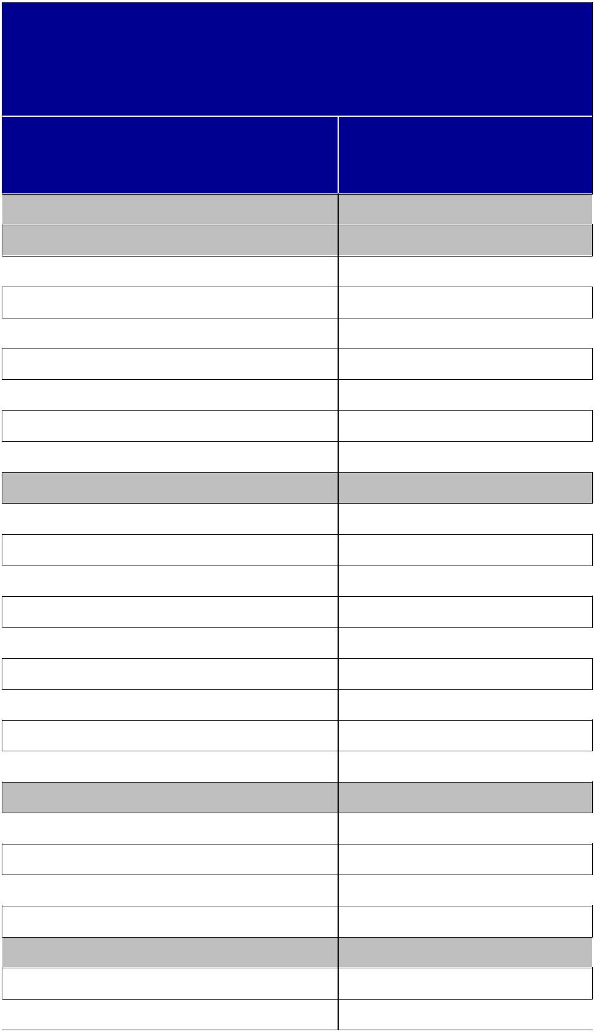

ESTIMATIVAS DA POPULAÇÃO RESIDENTE NO BRASIL E UNIDADES DA FEDERAÇÃO COM DATA DE REFERÊNCIA EM 1º DE JULHO DE 2012

BRASIL E UNIDADES DA

FEDERAÇÃO

Brasil

Região Norte
Rondônia

Acre
Amazonas

Roraima
Pará

Amapá
Tocantins

Região Nordeste
Maranhão

Piauí
Ceará

Rio Grande do Norte
Paraíba

Pernambuco
Alagoas

Sergipe
Bahia

Região Sudeste
Minas Gerais

Espírito Santo
Rio de Janeiro

São Paulo
Região Sul

Paraná
Santa Catarina

POPULAÇÃO

ESTIMADA

193 946 886

16 318 163
1 590 011

758 786
3 590 985

469 524
7 792 561

698 602
1 417 694

53 907 144
6 714 314

3 160 748
8 606 005

3 228 198
3 815 171

8 931 028
3 165 472

2 110 867
14 175 341

81 565 983
19 855 332

3 578 067
16 231 365

41 901 219
27 731 644

10 577 755
6 383 286

71

Brazil: An application of Porter’s Diamond and attractiveness analysis for French FDI
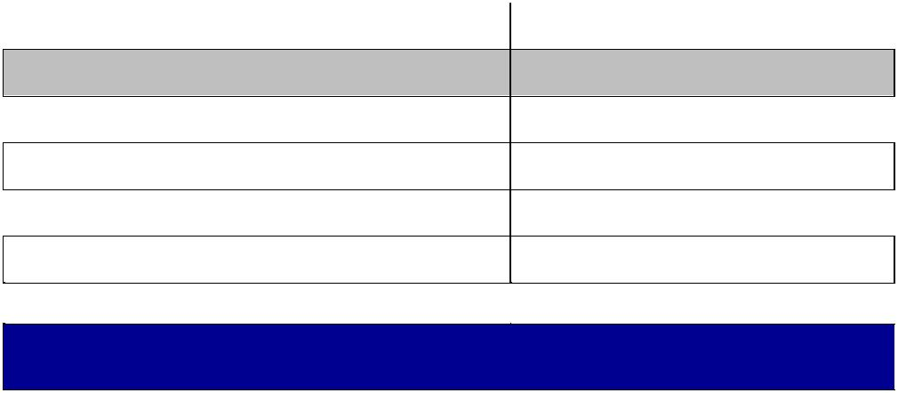

Rio Grande do Sul

Região Centro-Oeste

Mato Grosso do Sul

Mato Grosso
Goiás

Distrito Federal

10 770 603

14 423 952
2 505 088

3 115 336
6 154 996

2 648 532

Fonte: IBGE. Diretoria de Pesquisas - DPE - Coordenação de

População e Indicadores Sociais - COPIS.

7.2 Cluster of Internationally Competitive Brazil Industries, 2010, elaborated by the author (International Trade Centre, Products, 2010), (International Trade Centre, Services, 2010)


HS4 | HS4 Description
Code | HS4 Description

- Meat of bovine animals, frozen

- Meat of swine, fresh, chilled or frozen

Meat and edible offal, of the

- poultry of heading No 0105, fresh, chilled or frozen
Coffee, whether or not roasted or decaffeinated;

- coffee husks and skins; coffee substitutes containing coffee in any proportion

1005 |  |  |  | Maize (corn)
1201 |  |  |  | Soya beans, whether or not
 |  |  |  | broken
 |  |  |  | Soya-bean oil and its
1507 |  |  |  | fractions, whether or not
 |  |  |  | refined, but not chemically
 |  |  |  | modified
1602 |  |  |  | Other prepared or preserved
 |  |  |  | meat, meat offal or blood
 |  |  |  | Cane or beet sugar and
1701 |  |  |  | chemically pure sucrose, in
 |  |  |  | solid form
 |  |  |  | Fruit juices (including grape
 |  |  |  | must) and vegetable juices,
 |  |  |  | unfermented and not
2009 |  |  |  | containing added spirit,
 |  |  |  | whether or not containing
 |  |  |  | added sugar or other
 |  |  |  | sweetening matter
 |  |  | Undenatured ethyl alcohol
 |  |  | of an alcoholic strength by
 | 2207 |  | volume of 80 % vol or
 |  |  | higher; ethyl alcohol and
 |  |  | other spirits, denatured, of
 |  |  | any strength
 | 2304 |  | Soybean oilcake and other

Share of |  |  | Share of
Share of |  |  | Total
Total | Export | Import | Total |  | World | World
Total | Export | Import | Brazi- |  | World | World
World | Value * | Value * | Brazi- |  | Exports | Imports
World | Value * | Value * | lian |  | Exports | Imports
Exports |  |  | lian
Exports |  |  | Exports
23,13 | 3 376,28 | 648,27 | 1,71 | 14 593,91 |  | 13 169,49
4,90 | 1 226,58 | 0,91 | 0,62 | 25 028,24 |  | 24 948,03
27,59 | 5 952,03 | 30,53 | 3,02 | 21 570,95 |  | 20 270,12
21,42 | 5 203,35 | 215,18 | 2,64 | 24 292,89 |  | 23 961,84
9,50 | 2 214,96 | 759,78 | 1,12 | 23 326,15 |  | 25 694,03
27,76 | 11 043,00 | 435,59 | 5,60 | 39 777,90 |  | 44 378,03
13,83 | 1 347,66 | 139,37 | 0,68 | 9 748,00 |  | 8 924,81
10,37 | 1 268,18 | 33,75 | 0,64 | 12 224,70 |  | 11 921,96
43,06 | 12 761,41 | 3,50 | 6,47 | 29 635,40 |  | 29 760,45
14,43 | 1 924,69 | 276,41 | 0,98 | 13 339,53 |  | 13 547,72
16,86 | 1 014,29 | 413,22 | 0,51 | 6 014,32 |  | 5 539,51
21,16 | 4 719,37 | 128,74 | 2,39 | 22 302,29 |  | 24 184,35

Cluster

Food and Beverages

Food and Beverages

Food and Beverages

Food and Beverages

Food and Beverages

Food and Beverages

Food and Beverages

Food and Beverages

Food and Beverages

Food and Beverages

Food and Beverages

Food and

72

Brazil: An application of Porter’s Diamond and attractiveness analysis for French FDI


4802

3004

9403

2601

2603

6802

7108

7201

7202

7207

7208

7601

8307

102

8407

8409

8414

solid residue, wh/not ground

Uncoated paper and paperboard, of a kind used for writing, printing or other graphic purposes, and non-perforated punch-cards and punch tape paper, in rolls or rectangular (including square) sheets, of any size, other than paper of heading No 4801 or 4803

Medicaments (excluding goods of heading 3002,
3005 or 3006) consisting of mixed or unmixed products for therapeutic or prophylactic uses, put up in measured doses (including those in the form of transdermal administration systems) or in forms or packings
Other furniture and parts thereof
Iron ores and concentrates, including roasted iron pyrites

Copper ores and

concentrates
Worked monumental or building stone (except slate) and articles thereof, other than goods of heading 6801; mosaic cubes and the like, of natural stone (including slate), whether or not on a backing; artificially coloured granules, chippings and powder, of

Gold (including gold plated with platinum), unwrought or in semi-manufactured forms, or in powder form

Pig iron and spiegeleisen in pigs, blocks or other primary forms

Ferro-alloys

Semi-finished products of iron or non-alloy steel
Flat-rolled products of iron or non-alloy steel, of a width of 600 mm or more, hot-rolled, not clad, plated or coated

Unwrought aluminium

Flexible tubing of base metal, with or without fittings

Live bovine animals

Spark-ignition reciprocating or rotary internal combustion piston engines
Parts suitable for use solely or principally with the engines of heading No 8407 or 8408

Air or vacuum pumps, air or other gas compressors and fans; ventilating or recycling hoods incorporating a fan, whether

4,14 934,19 2 132,97 0,47 22 573,41 22 886,59

0,29 898,05 31 449,41 0,46 314 066,32 320 212,90

0,89 | 582,28 | 863,43 | 0,30 | 65 229,07 |  | 63 764,24
27,91 | 28 911,88 | 138,01 | 14,65 | 103 582,52 |  | 130 619,66
2,75 | 1 237,74 | 9 654,49 | 0,63 | 45 046,57 |  | 45 502,91

6,26 633,16 393,22 0,32 10 107,21 9 293,74

1,26 | 1 801,95 | 22,52 | 0,91 | 143 048,34 |  | 115 318,60
20,20 | 971,14 | 3,52 | 0,49 | 4 807,82 |  | 5 641,38
7,58 | 2 038,95 | 2 513,75 | 1,03 | 26 894,89 |  | 29 004,46
8,27 | 2 434,34 | 224,63 | 1,23 | 29 431,51 |  | 28 585,95
1,38 | 770,17 | 9 481,39 | 0,39 | 55 695,29 |  | 57 980,40
2,74 | 1 280,35 | 1 322,01 | 0,65 | 46 799,07 |  | 48 653,52
25,91 | 649,31 | 665,84 | 0,33 | 2 506,39 |  | 1 810,63
8,79 | 658,66 | 45,00 | 0,33 | 7 492,63 |  | 7 845,73
1,81 | 641,37 | 4 383,61 | 0,32 | 35 416,62 |  | 38 813,15
2,58 | 1 446,94 | 12 238,97 | 0,73 | 56 079,88 |  | 57 855,99
1,53 | 932,22 | 14 070,30 | 0,47 | 60 774,47 |  | 62 054,85

Beverages

Forest products

Health care

Housing/H ousehold

Materials/ Metals

Materials/ Metals

Materials/ Metals

Materials/ Metals

Materials/ Metals

Materials/ Metals

Materials/ Metals

Materials/ Metals

Materials/ Metals

Materials/ Metals

Multiple business

Multiple business

Multiple business

Multiple business

73

Brazil: An application of Porter’s Diamond and attractiveness analysis for French FDI


8429

8481

8501

8517

8701

2401

2709

2710

2818

3901

4703

4104

4107

5201

6403

or not fitted with filters

Self-propelled bulldozers, angledozers, graders, levellers, scrapers, mechanical shovels, excavators, shovel loaders, tamping machines and road rollers

Taps, cocks, valves and similar appliances for pipes, boiler shells, tanks, vats or the like, including pressure-reducing valves and thermostatically controlled valves

Electric motors and generators (excluding generating sets)
Electrical apparatus for line

telephony or line
telegraphy, including line

telephone sets with cordless
handsets and
telecommunication

apparatus for carrier-current
line systems or for digital
line systems; videophones

Tractors (other than tractors of heading 8709)
Unmanufactured tobacco; tobacco refuse
Crude oil from petroleum and bituminous minerals

Petroleum oils and oils obtained from bituminous minerals, other than crude; preparations not elsewhere specified or included, containing by weight 70 % or more of petroleum oils or of oils obtained from bituminous minerals, these oils being the basic con
Artificial corundum, whether or not chemically defined; aluminium oxide; aluminium hydroxide

Polymers of ethylene, in primary forms
Chemical wood pulp, soda or sulphate, other than dissolving grades
Tanned or crust hides and skins of bovine (including buffalo) or equine animals, without hair on, whether or not split, but not further prepared
Leather further prepared after tanning or crusting, including parchment-dressed leather, of bovine (including buffalo) or equine animals, without hair on, whether or not split, other than leather of heading 4114

Cotton, not carded or combed
Footwear with outer soles of rubber, plastics, leather or composition leather and uppers of leather

3,66 | 1 349,69 | 8 411,85 | 0,68 | 36 853,60 |  | 37 692,24
0,88 | 576,00 | 10 577,97 | 0,29 | 65 133,59 |  | 68 719,10
1,79 | 721,84 | 5 912,87 | 0,37 | 40 358,65 |  | 41 512,82
0,39 | 1 277,74 | 33 594,31 | 0,65 | 324 300,34 |  | 352 760,09
2,84 | 1 047,87 | 1 233,30 | 0,53 | 36 883,18 |  | 33 030,12
24,98 | 2 706,67 | 679,82 | 1,37 | 10 835,76 |  | 11 686,13
1,44 | 16 293,42 | 100 974,46 | 8,26 |  | 1 130 423,3 | 1 324 378,60
 |  |  |  |  | 5 | 1 324 378,60
0,45 | 3 060,74 | 111 258,56 | 1,55 | 684 373,55 |  | 645 886,48
13,04 | 1 774,39 | 501,94 | 0,90 | 13 606,51 |  | 12 572,63
1,82 | 1 113,05 | 9 982,20 | 0,56 | 60 995,41 |  | 64 482,50
16,33 | 4 434,24 | 3 251,04 | 2,25 | 27 156,89 |  | 29 781,37
13,50 | 736,58 | 397,14 | 0,37 | 5 457,26 |  | 5 382,71

9,06 982,53 70,49 0,50 10 843,11 10 039,88

5,48 | 821,55 | 683,05 | 0,42 | 14 993,99 |  | 15 098,79
2,02 | 924,30 | 809,40 | 0,47 | 45 764,19 |  | 48 662,45

Multiple business

Multiple business

Multiple business

Multiple business

Multiple business

Personal

Petroleum/ Chemicals

Petroleum/ Chemicals

Petroleum/ Chemicals

Petroleum/ Chemicals

Petroleum/ Chemicals

Textile/Ap parel

Textile/Ap parel

Textile/Ap parel

Textile/Ap parel

74

Brazil: An application of Porter’s Diamond and attractiveness analysis for French FDI


4011 |  | New pneumatic tyres, of
4011 |  | rubber
 |  | Motor cars and other motor
 |  | vehicles principally
 |  | designed for the transport of
8703 |  | persons (other than those of
 |  | heading 8702), including
 |  | station wagons and racing
 |  | cars
8704 |  | Motor vehicles for the
8704 |  | transport of goods
 |  | Chassis, with engines, for
8706 |  | vehicles of positions 87.01
 |  | through 87.05
 |  | Parts and accessories of the
8708 |  | motor vehicles of heading
 |  | 8701 to 8705
 | Other aircraft (for example,
 | helicopters, aeroplanes);
8802 | spacecraft (including
8802 | satellites) and suborbital
 | and spacecraft launch
 | vehicles
- Other business services
- Travel
- Transportation
- Financial services
- Government services, n.i.e.
- Communications services
- Insurance services

266 | Royalties and license fees
- Computer and information services
- Personal, cultural and recreational services

²⁴⁹ Construction services

1,91 | 1 277,12 | 12 867,16 | 0,65 | 66 899,03
0,79 | 4 416,14 | 83 049,81 | 2,24 | 556 013,66
1,81 | 1 686,89 | 19 775,19 | 0,85 | 92 994,59
17,82 | 635,60 | 177,24 | 0,32 | 3 566,65
1,16 | 3 381,64 | 49 285,00 | 1,71 | 290 821,10
4,63 | 3 999,05 | 10 806,30 | 2,03 | 86 378,58
1,63 | 15 776,50 | 20 873,50 | 49,58 | 970 186,54
0,62 | 5 918,85 | 16 421,70 | 18,60 | 947 549,57
0,62 | 4 931,37 | 11 338,70 | 15,50 | 800 980,38
0,75 | 2 072,62 | 1 678,87 | 6,51 | 277 784,88
2,29 | 1 526,90 | 2 845,75 | 4,80 | 66 579,06
0,47 | 435,00 | 271,16 | 1,37 | 93 269,22
0,43 | 416,03 | 1 528,76 | 1,31 | 97 146,04
0,16 | 397,21 | 2 850,25 | 1,25 | 254 130,69
0,10 | 209,84 | 3 505,43 | 0,66 | 211 162,64
0,35 | 108,26 | 1 271,47 | 0,34 | 31 130,09
0,03 | 28,54 | 6,48 | 0,09 | 99 470,20

66 552,33 | Transportat
66 552,33 | ion
544 542,92 | Transportat
544 542,92 | ion
98 897,49 | Transportat
98 897,49 | ion
3 271,47 | Transportat
3 271,47 | ion
280 104,25 | Transportat
280 104,25 | ion
96 055,42 | Transportat
96 055,42 | ion
833 328,93 | Services
856 375,67 | Services
976 774,81 | Services
118 482,88 | Services
118 325,14 | Services
83 205,03 | Services
169 097,57 | Services
266 344,58 | Services
106 290,82 | Services
37 092,53 | Services
77 411,23 | Services

75

Brazil: An application of Porter’s Diamond and attractiveness analysis for French FDI

7.3 The Global Competitiveness Report 2013-2014 (World Economic Forum, 2013)
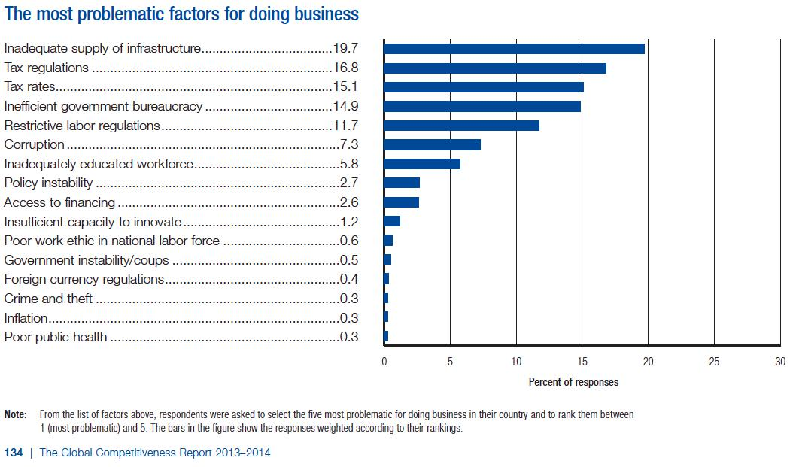

7.4 Country Attractiveness Index 2013 (Groh, Liechtenstein, & Lieser, 2013)
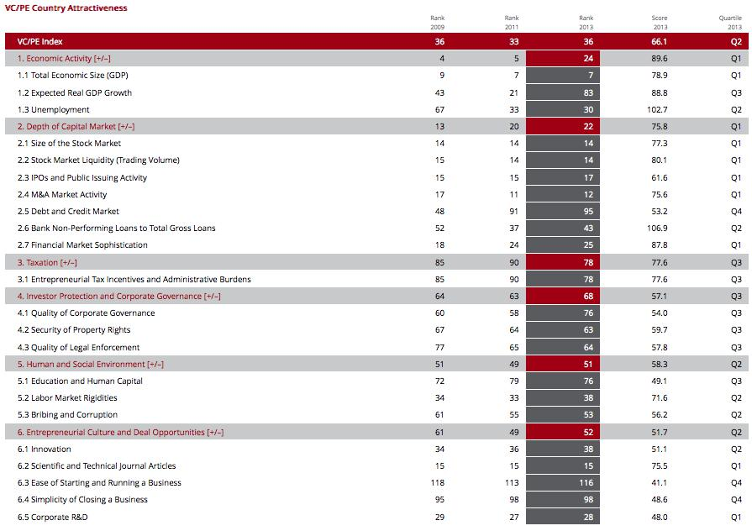

76

